Review of Water Thresholds - Gnangara

Christopher Kavazos, Grant Buller, Pierre Horwitz, Ray Froend

16/09/2019

# Introduction

This report details an analysis that reviews the ecological impacts of revised proposed water level thresholds for wetlands in the Gnangara mound.

Full analysis can be found [here] (<https://github.com/ChrisKav/DWER-Thresholds-2019>)

# EMP 173

Five year summaries of surface water level data at EMP 173

| Period | Mean max seasonal level (mAHD) | Mean min seasonal level (mAHD) | Mean seasonal change (m) | Month of maximum | Month of minimum | Mean max to min (days) |
| --- | --- | --- | --- | --- | --- | --- |
| 08/1994 - 07/1999 | 51.122 | 50.209 | 0.913 | October | March | 195.667 |
| 08/1999 - 07/2004 | 51.086 | 50.410 | 0.676 | September | April | 157.600 |
| 08/2004 - 07/2009 | 51.036 | 50.410 | 0.626 | August | January | 79.000 |
| 08/2009 - 07/2014 | 50.732 | 50.400 | 0.332 | October | February | 60.800 |
| 08/2014 - 07/2019 | 50.804 | 50.400 | 0.404 | September | January | 85.600 |

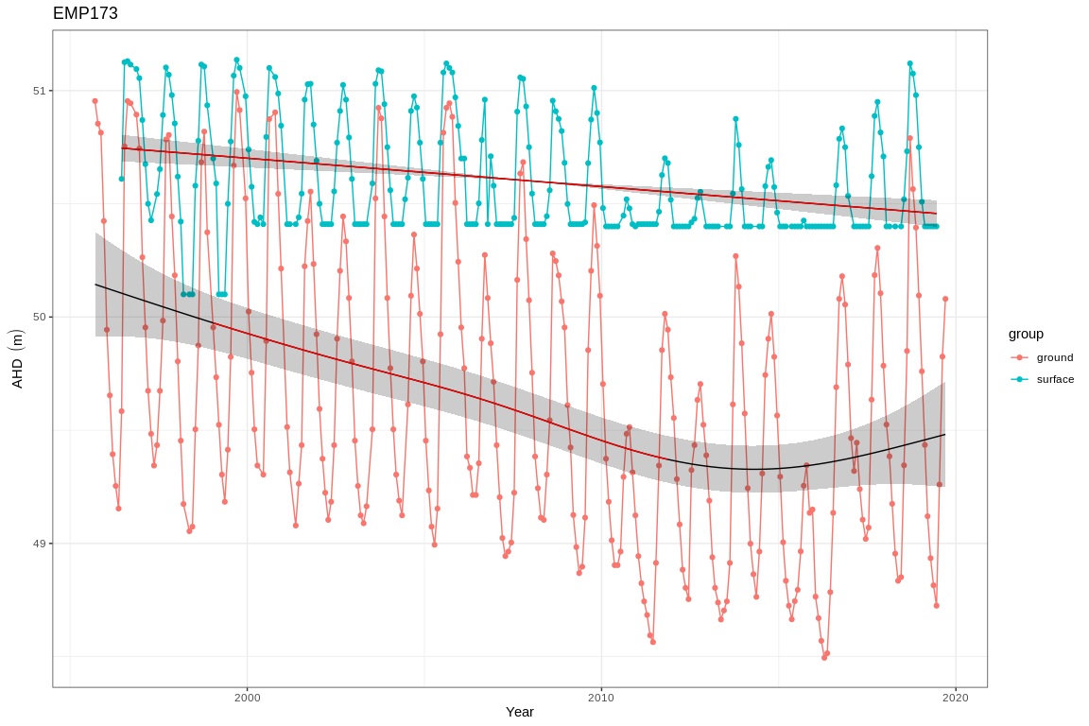

Ground and surface water levels recorded at bores and staff gauges in the vicinity of EMP 173

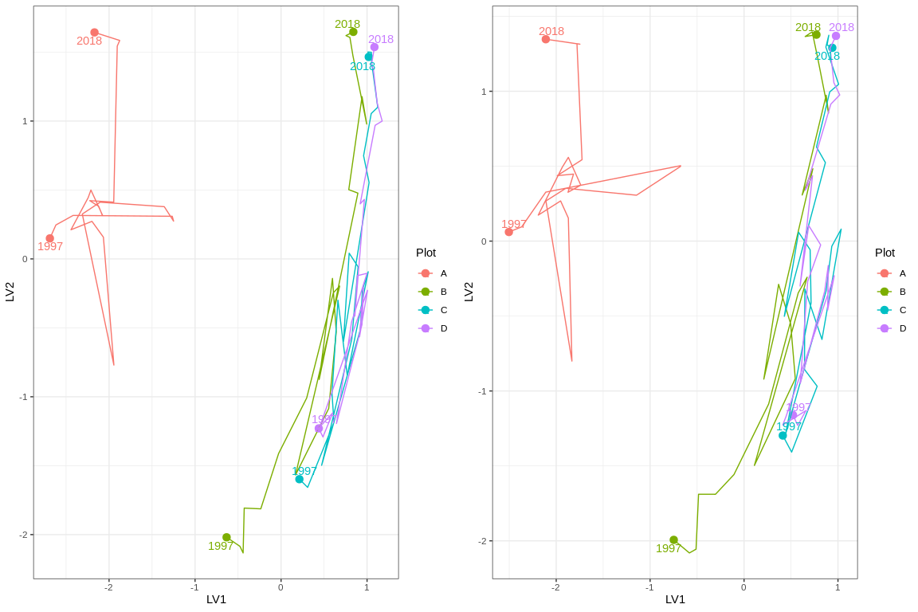

Ordination plot with full residual model on the left and a model on the right showing residual variation after the effect of groundwater levels were accounted for

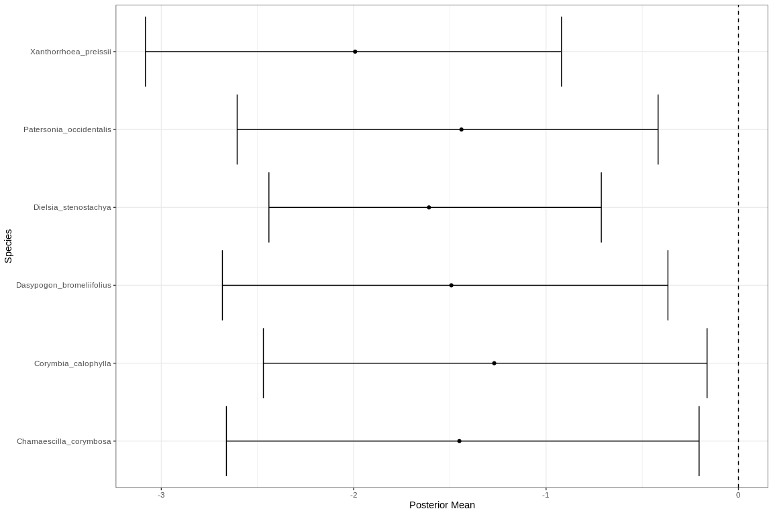

Mean regression coefficients (dots) and 95% credible intervals (bars) for effect of groundwater level on vegetation species cover abundances. Only those species with coefficients significanlty different to zero are shown

# EMP 78

Five year summaries of surface water level data at EMP 78

| Period | Mean max seasonal level (mAHD) | Mean min seasonal level (mAHD) | Mean seasonal change (m) | Month of maximum | Month of minimum | Mean max to min (days) |
| --- | --- | --- | --- | --- | --- | --- |
| 08/1994 - 07/1999 | 66.191 | 66.021 | 0.170 | July | June | -27.000 |
| 08/1999 - 07/2004 | 66.231 | 65.831 | 0.400 | October | May | 234.800 |
| 08/2004 - 07/2009 | 65.975 | 65.619 | 0.356 | November | April | 227.600 |
| 08/2009 - 07/2014 | 65.415 | 65.109 | 0.306 | October | July | 212.800 |
| 08/2014 - 07/2019 | 65.177 | 64.891 | 0.286 | November | May | 170.400 |

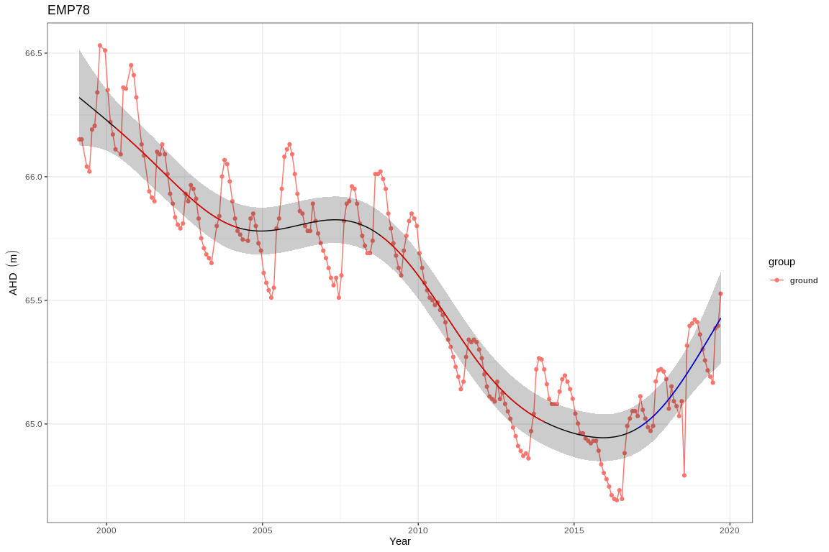

Ground and surface water levels recorded at bores and staff gauges in the vicinity of EMP 78

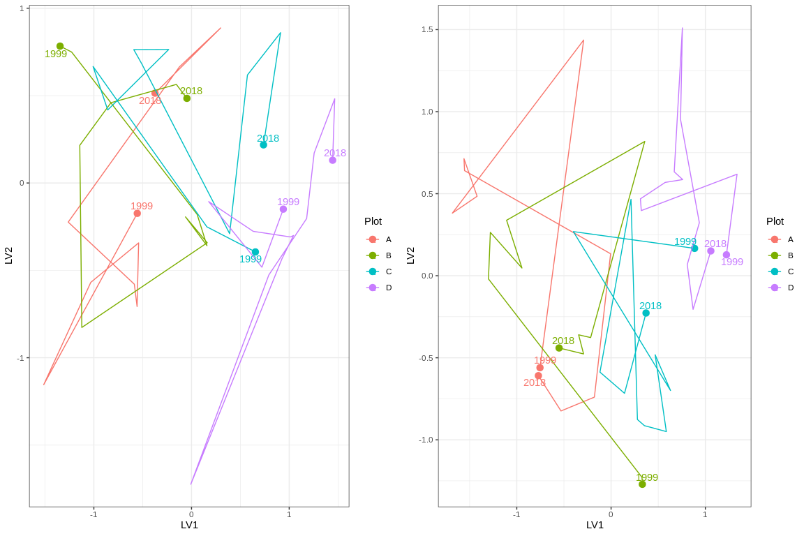

Ordination plot with full residual model on the left and a model on the right showing residual variation after the effect of groundwater levels were accounted for

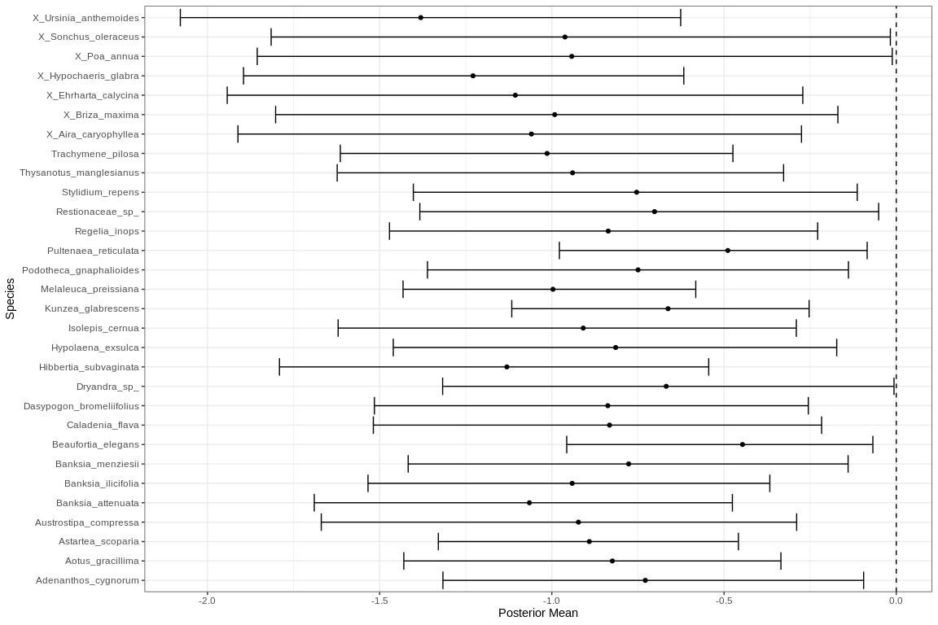

Mean regression coefficients (dots) and 95% credible intervals (bars) for effect of groundwater level on vegetation species cover abundances. Only those species with coefficients significanlty different to zero are shown

# Gingin

Five year summaries of surface water level data at Gingin

| Period | Mean max seasonal level (mAHD) | Mean min seasonal level (mAHD) | Mean seasonal change (m) | Month of maximum | Month of minimum | Mean max to min (days) |
| --- | --- | --- | --- | --- | --- | --- |
| 08/1994 - 07/1999 | 39.628 | 39.174 | 0.454 | October | July | 218.800 |
| 08/1999 - 07/2004 | 39.162 | 38.644 | 0.518 | December | May | 198.200 |
| 08/2004 - 07/2009 | 38.534 | 38.106 | 0.428 | October | June | 212.600 |
| 08/2009 - 07/2014 | 37.930 | 37.530 | 0.400 | October | May | 221.400 |
| 08/2014 - 07/2019 | 37.783 | 37.352 | 0.431 | November | May | 141.000 |

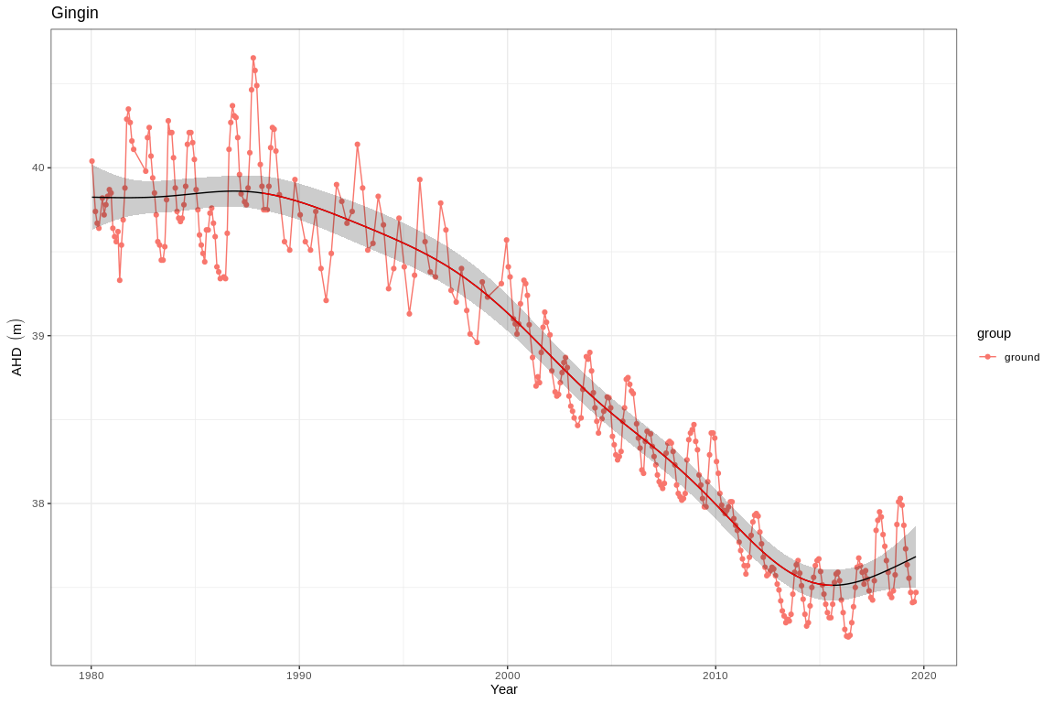

Ground and surface water levels recorded at bores and staff gauges in the vicinity of Gingin

# Goollelal

Five year summaries of surface water level data at Goollelal

| Period | Mean max seasonal level (mAHD) | Mean min seasonal level (mAHD) | Mean seasonal change (m) | Month of maximum | Month of minimum | Mean max to min (days) |
| --- | --- | --- | --- | --- | --- | --- |
| 08/1994 - 07/1999 | 27.534 | 26.754 | 0.780 | October | May | 206.800 |
| 08/1999 - 07/2004 | 27.485 | 26.684 | 0.800 | September | March | 206.400 |
| 08/2004 - 07/2009 | 27.379 | 26.628 | 0.751 | September | April | 137.400 |
| 08/2009 - 07/2014 | 27.244 | 26.513 | 0.731 | October | April | 189.600 |
| 08/2014 - 07/2019 | 27.386 | 26.708 | 0.678 | November | April | 138.600 |

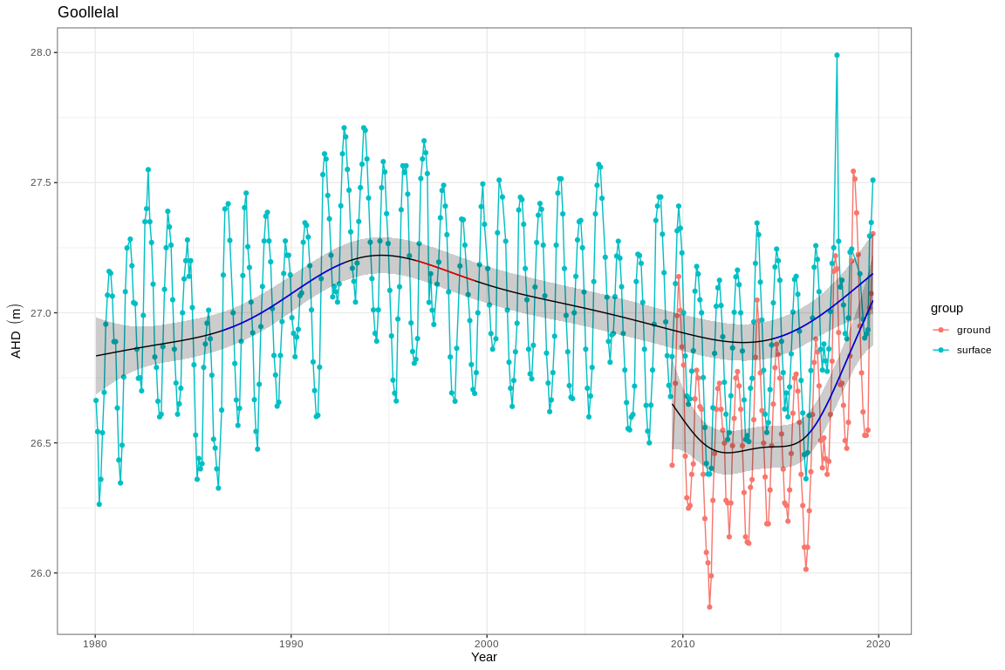

Ground and surface water levels recorded at bores and staff gauges in the vicinity of Goollelal

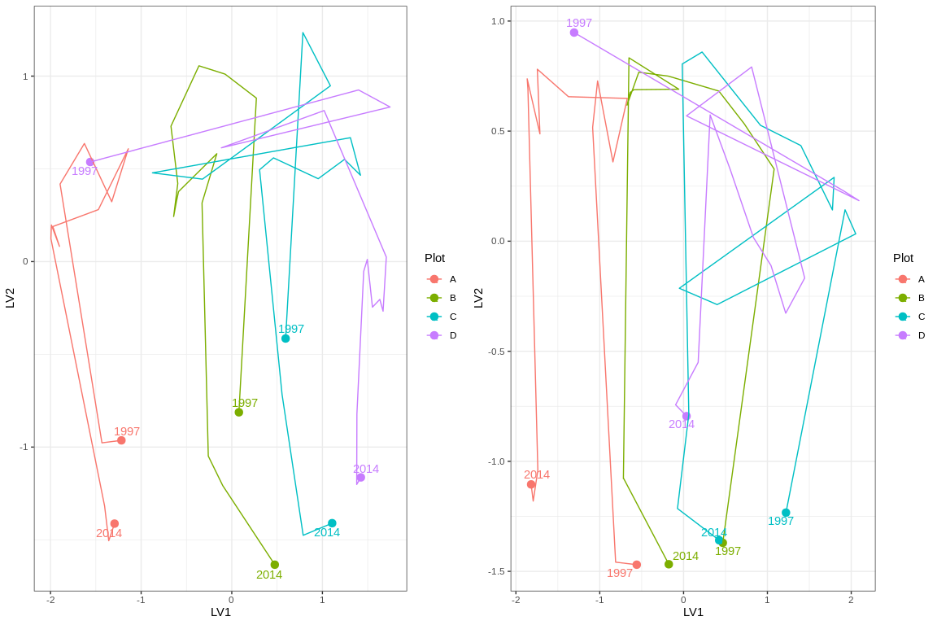

Ordination plot with full residual model on the left and a model on the right showing residual variation after the effect of groundwater levels were accounted for

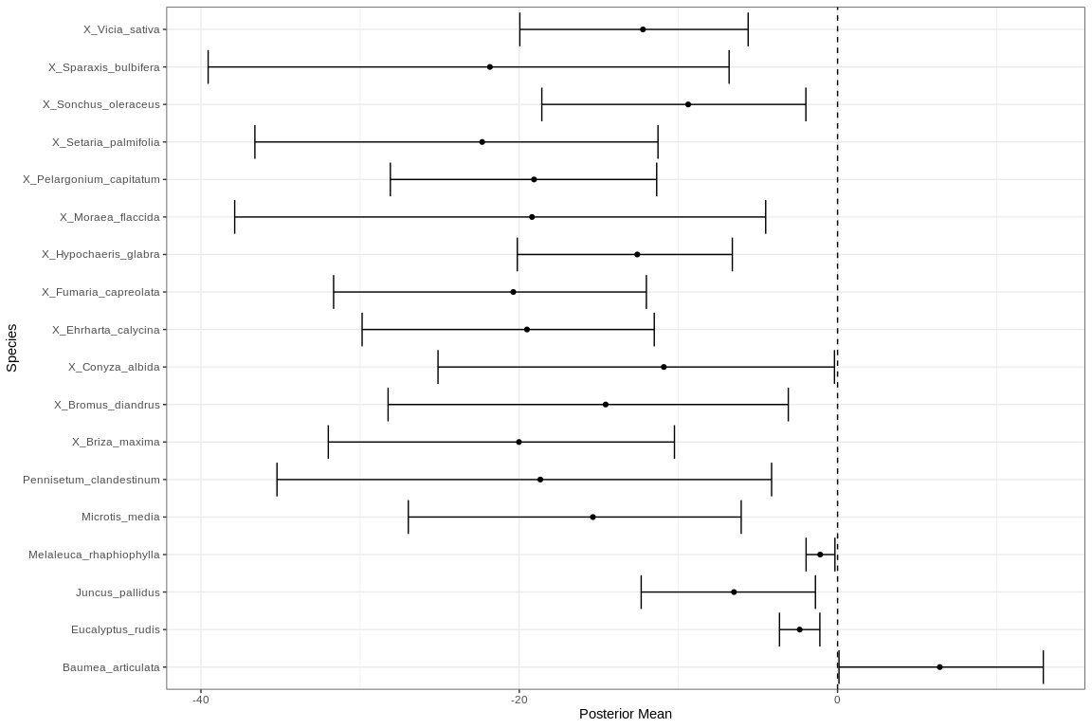

Mean regression coefficients (dots) and 95% credible intervals (bars) for effect of groundwater level on vegetation species cover abundances. Only those species with coefficients significanlty different to zero are shown

# Gwelup

Five year summaries of surface water level data at Gwelup

| Period | Mean max seasonal level (mAHD) | Mean min seasonal level (mAHD) | Mean seasonal change (m) | Month of maximum | Month of minimum | Mean max to min (days) |
| --- | --- | --- | --- | --- | --- | --- |
| 08/1994 - 07/1999 | 7.515 | 5.661 | 1.854 | September | April | 238.800 |
| 08/1999 - 07/2004 | 6.664 | 5.146 | 1.518 | October | April | 171.600 |
| 08/2004 - 07/2009 | 6.322 | 5.000 | 1.322 | September | December | 14.000 |
| 08/2009 - 07/2014 | 6.146 | 4.972 | 1.174 | October | January | 138.400 |
| 08/2014 - 07/2019 | 7.251 | 5.592 | 1.659 | October | April | 221.800 |

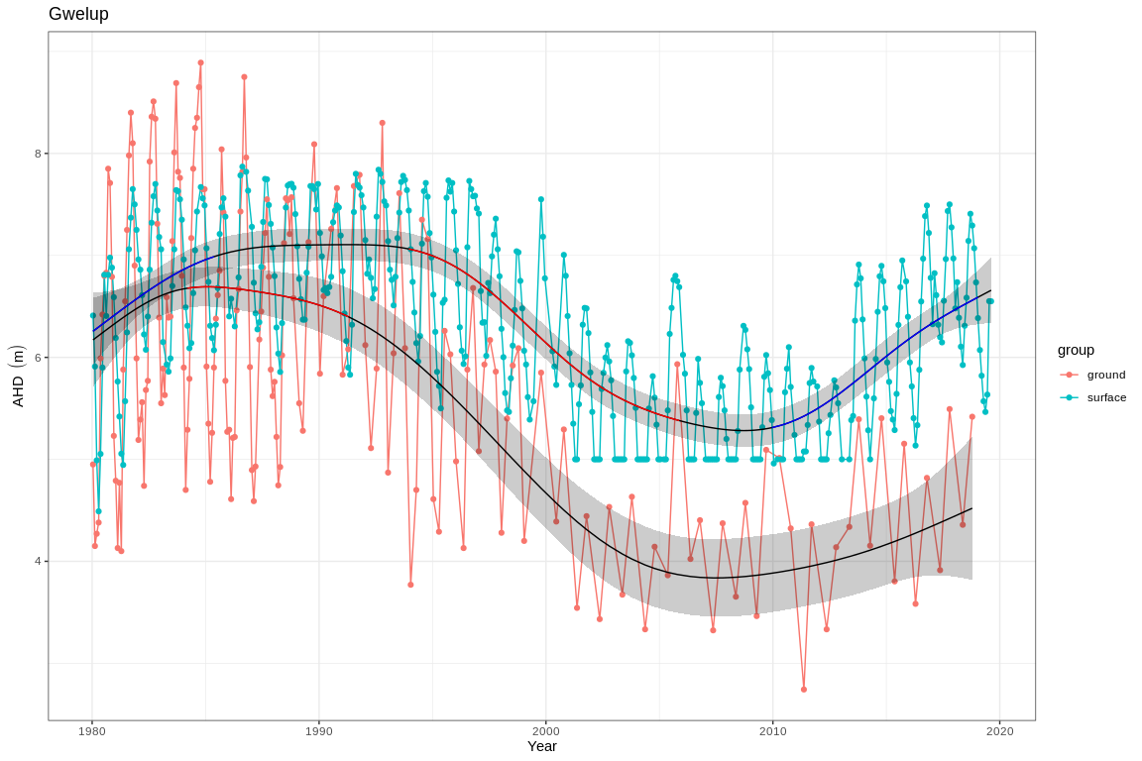

Ground and surface water levels recorded at bores and staff gauges in the vicinity of Gwelup

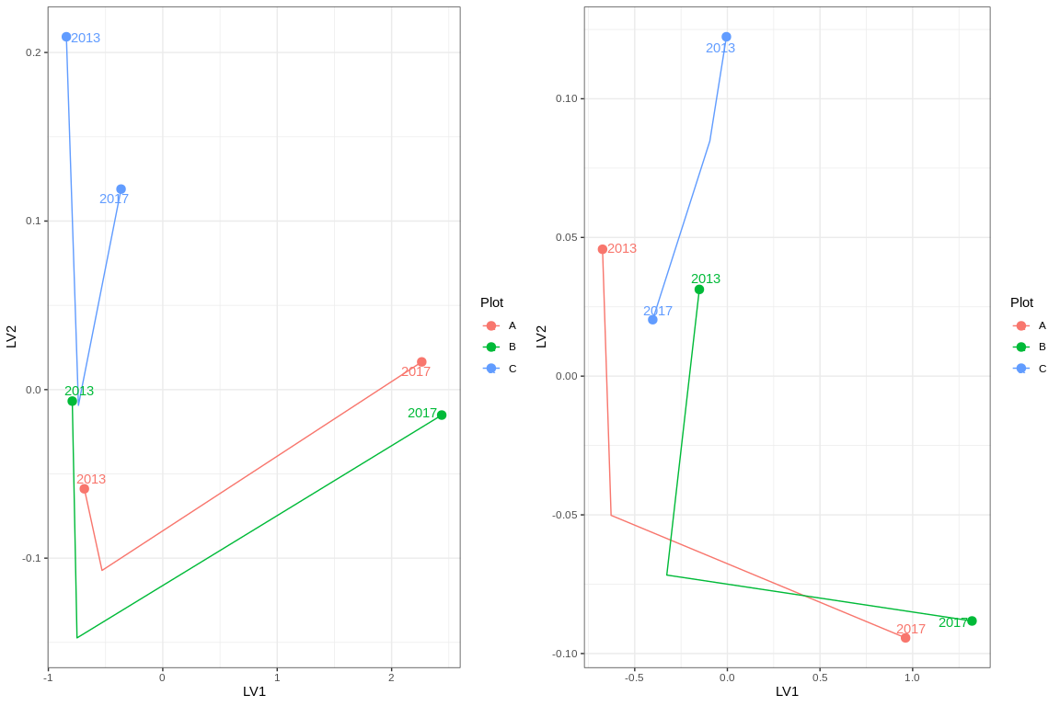

Ordination plot with full residual model on the left and a model on the right showing residual variation after the effect of groundwater levels were accounted for

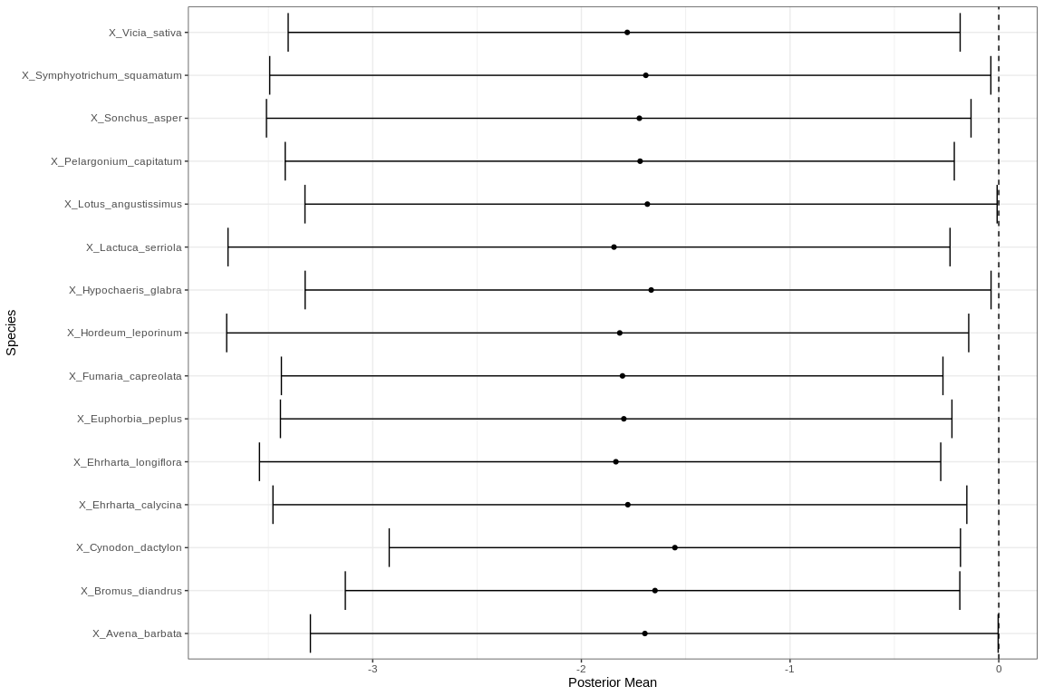

Mean regression coefficients (dots) and 95% credible intervals (bars) for effect of groundwater level on vegetation species cover abundances. Only those species with coefficients significanlty different to zero are shown

# Jandabup

Five year summaries of surface water level data at Jandabup

| Period | Mean max seasonal level (mAHD) | Mean min seasonal level (mAHD) | Mean seasonal change (m) | Month of maximum | Month of minimum | Mean max to min (days) |
| --- | --- | --- | --- | --- | --- | --- |
| 08/1994 - 07/1999 | 44.914 | 44.109 | 0.805 | October | February | 155.800 |
| 08/1999 - 07/2004 | 44.876 | 44.232 | 0.644 | September | March | 151.200 |
| 08/2004 - 07/2009 | 44.843 | 44.248 | 0.595 | July | March | 108.000 |
| 08/2009 - 07/2014 | 44.674 | 44.156 | 0.518 | October | January | 164.400 |
| 08/2014 - 07/2019 | 44.744 | 44.231 | 0.513 | September | March | 182.000 |

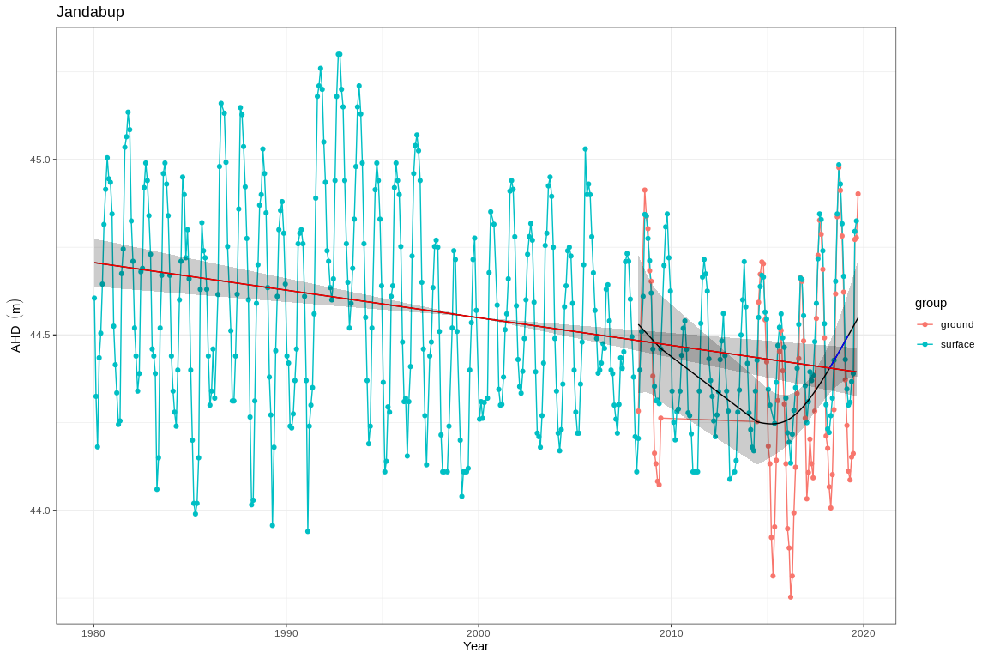

Ground and surface water levels recorded at bores and staff gauges in the vicinity of Jandabup

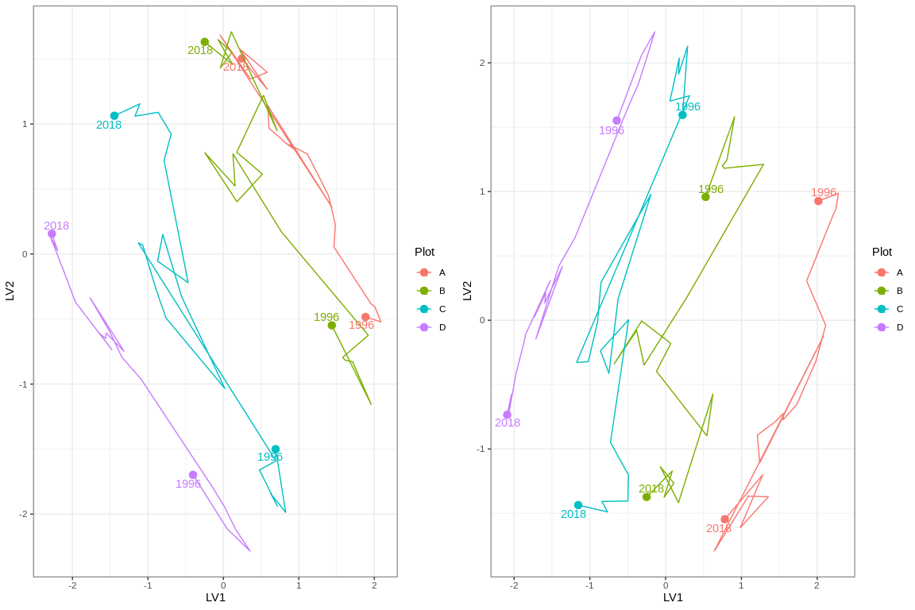

Ordination plot with full residual model on the left and a model on the right showing residual variation after the effect of groundwater levels were accounted for

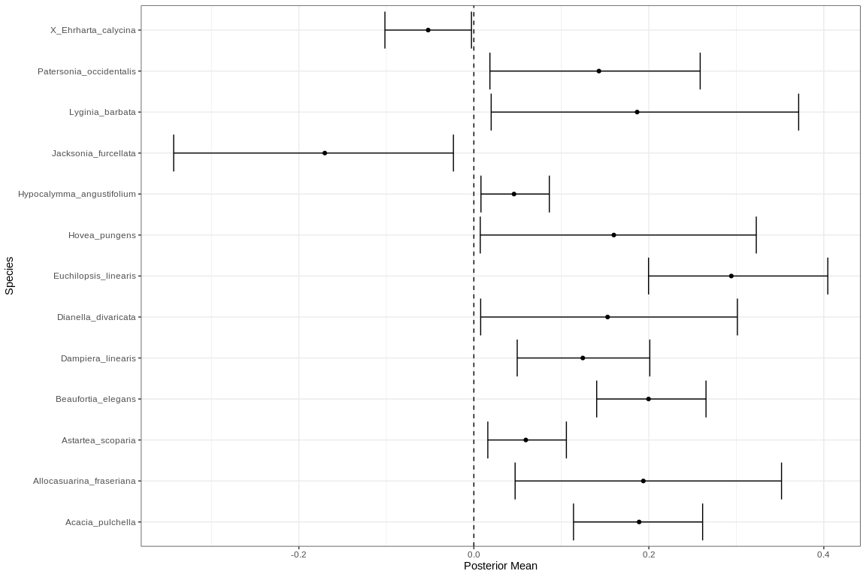

Mean regression coefficients (dots) and 95% credible intervals (bars) for effect of groundwater level on vegetation species cover abundances. Only those species with coefficients significanlty different to zero are shown

# Joondalup

Five year summaries of surface water level data at Lake Joondalup

| Period | Mean max seasonal level (mAHD) | Mean min seasonal level (mAHD) | Mean seasonal change (m) | Month of maximum | Month of minimum | Mean max to min (days) |
| --- | --- | --- | --- | --- | --- | --- |
| 08/1994 - 07/1999 | 17.184 | 16.225 | 0.959 | September | April | 213.400 |
| 08/1999 - 07/2004 | 16.980 | 16.064 | 0.916 | October | April | 179.400 |
| 08/2004 - 07/2009 | 16.916 | 16.123 | 0.792 | October | April | 181.000 |
| 08/2009 - 07/2014 | 16.884 | 16.064 | 0.820 | October | March | 172.800 |
| 08/2014 - 07/2019 | 17.162 | 16.483 | 0.679 | October | April | 205.800 |

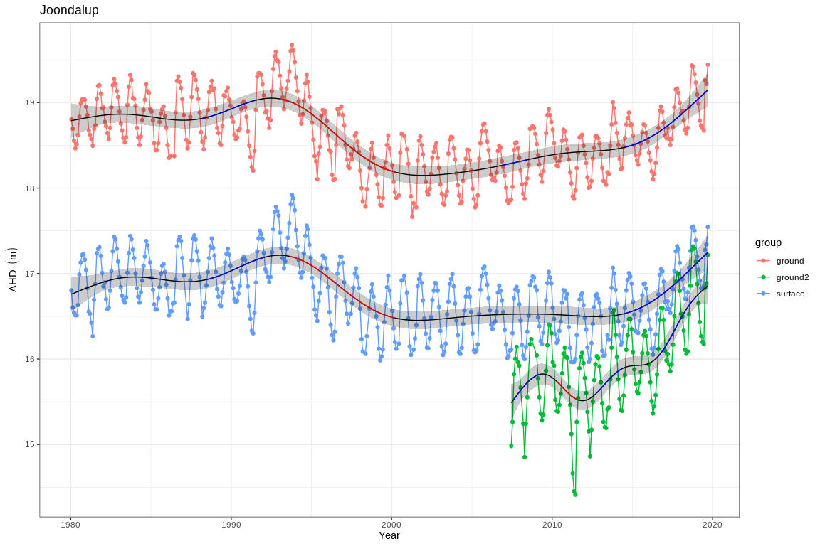

Ground and surface water levels recorded at bores and staff gauges in the vicinity of Joondalup

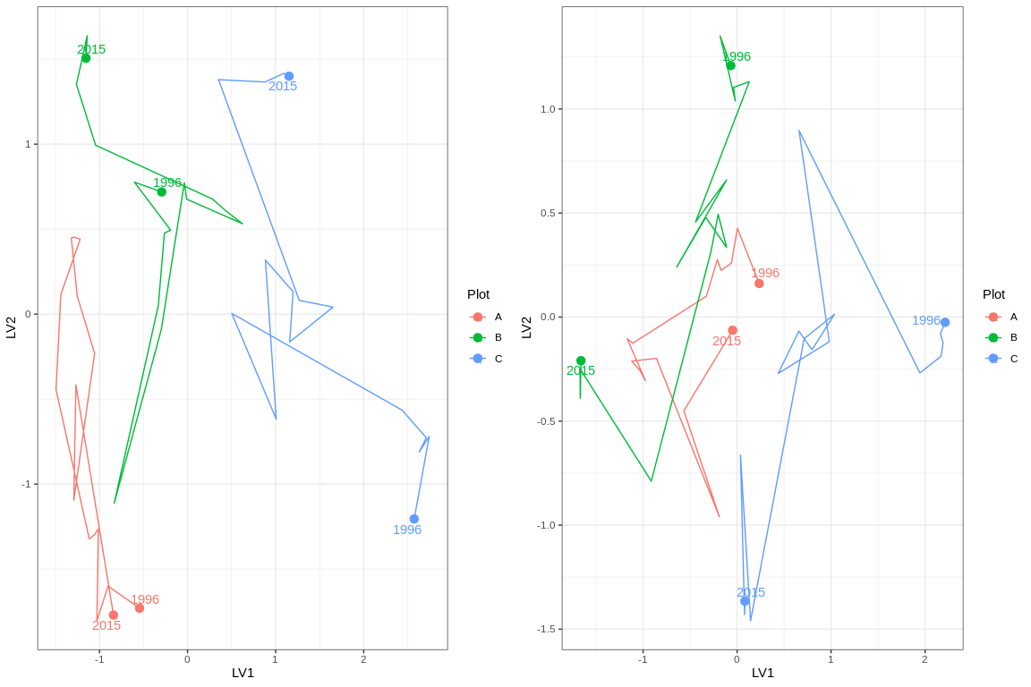

Ordination plot with full residual model on the left and a model on the right showing residual variation after the effect of groundwater levels were accounted for

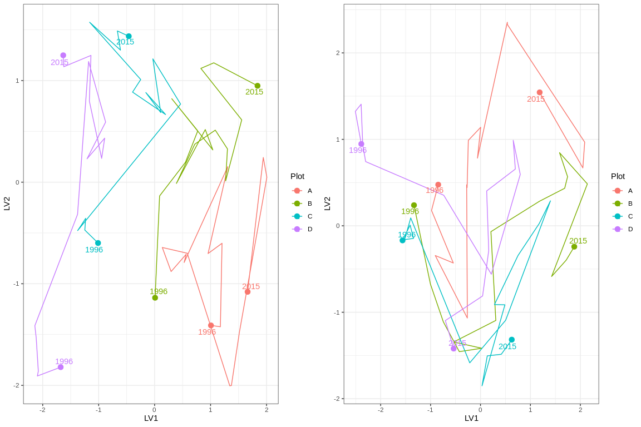

Ordination plot with full residual model on the left and a model on the right showing residual variation after the effect of groundwater levels were accounted for

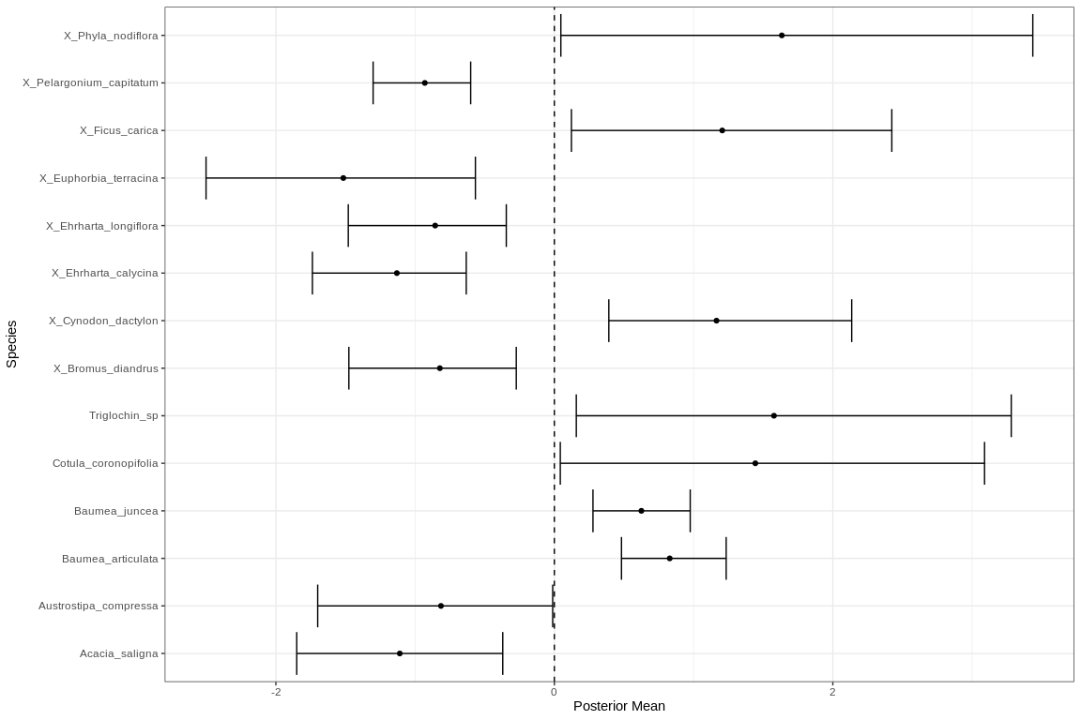

Mean regression coefficients (dots) and 95% credible intervals (bars) for effect of groundwater level on vegetation species cover abundances. Only those species with coefficients significanlty different to zero are shown

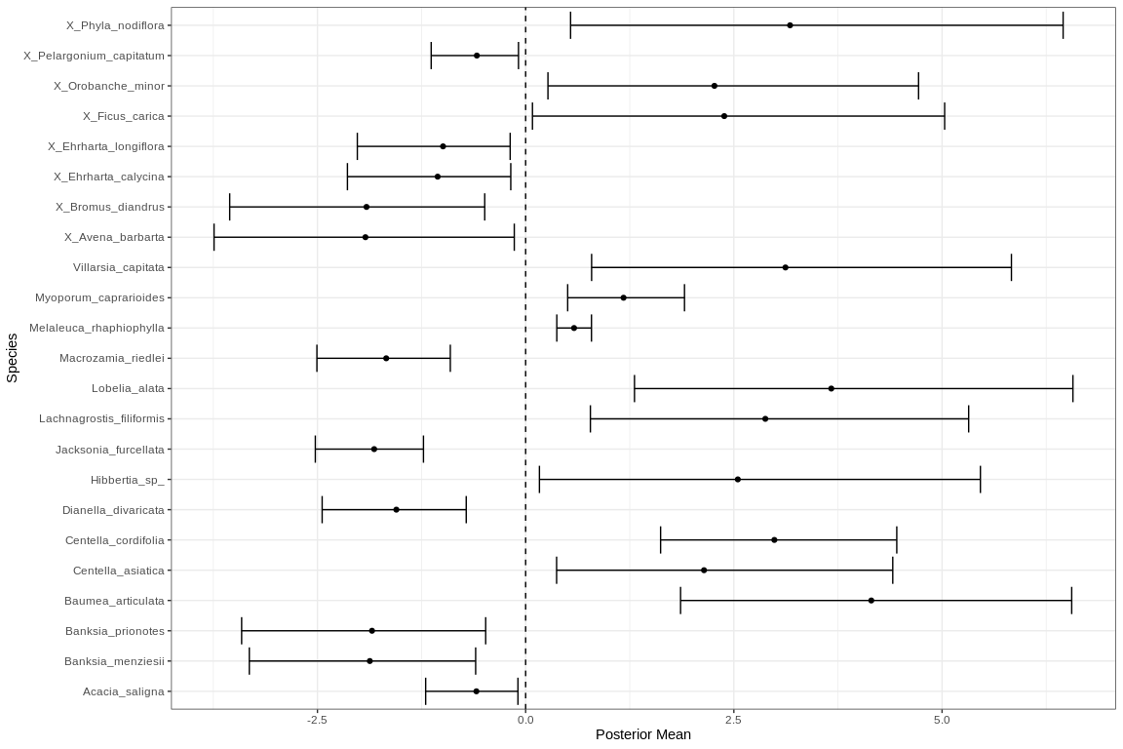

Mean regression coefficients (dots) and 95% credible intervals (bars) for effect of groundwater level on vegetation species cover abundances. Only those species with coefficients significanlty different to zero are shown

# Lexia 186

Five year summaries of surface water level data at Lexia 186

| Period | Mean max seasonal level (mAHD) | Mean min seasonal level (mAHD) | Mean seasonal change (m) | Month of maximum | Month of minimum | Mean max to min (days) |
| --- | --- | --- | --- | --- | --- | --- |
| 08/1994 - 07/1999 | 3.169 | 1.831 | 1.337 | September | May | 212.600 |
| 08/1999 - 07/2004 | 2.770 | 1.794 | 0.976 | October | March | 167.800 |
| 08/2004 - 07/2009 | 2.386 | 1.996 | 0.390 | September | November | 11.800 |
| 08/2009 - 07/2014 | 1.981 | 1.000 | 0.981 | October | July | 87.800 |
| 08/2014 - 07/2019 | 1.967 | 1.000 | 0.967 | September | January | 124.400 |

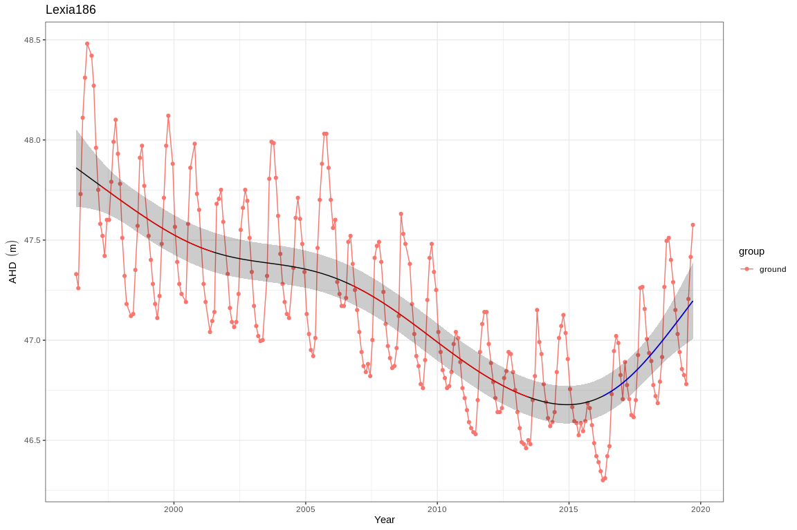

Ground and surface water levels recorded at bores and staff gauges in the vicinity of Lexia 186

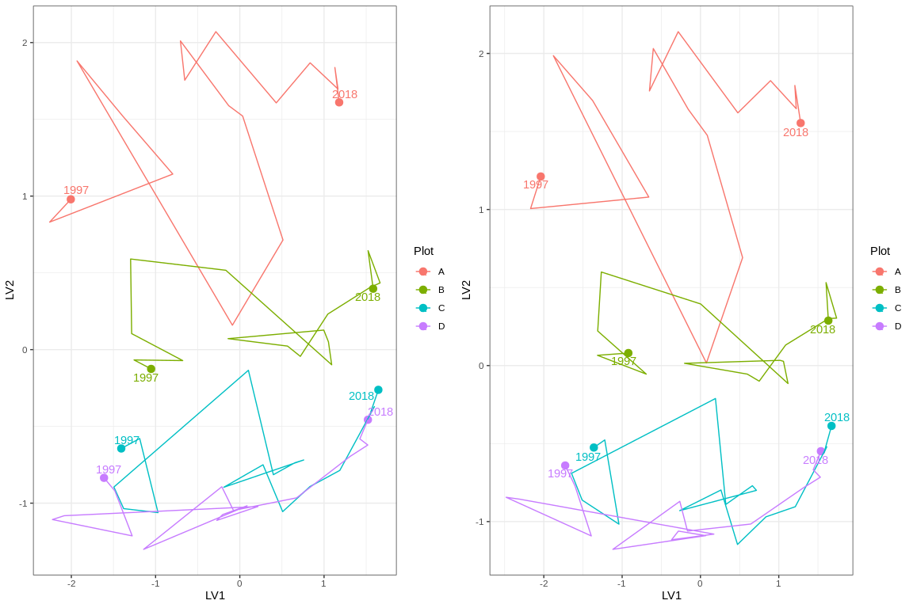

Ordination plot with full residual model on the left and a model on the right showing residual variation after the effect of groundwater levels were accounted for

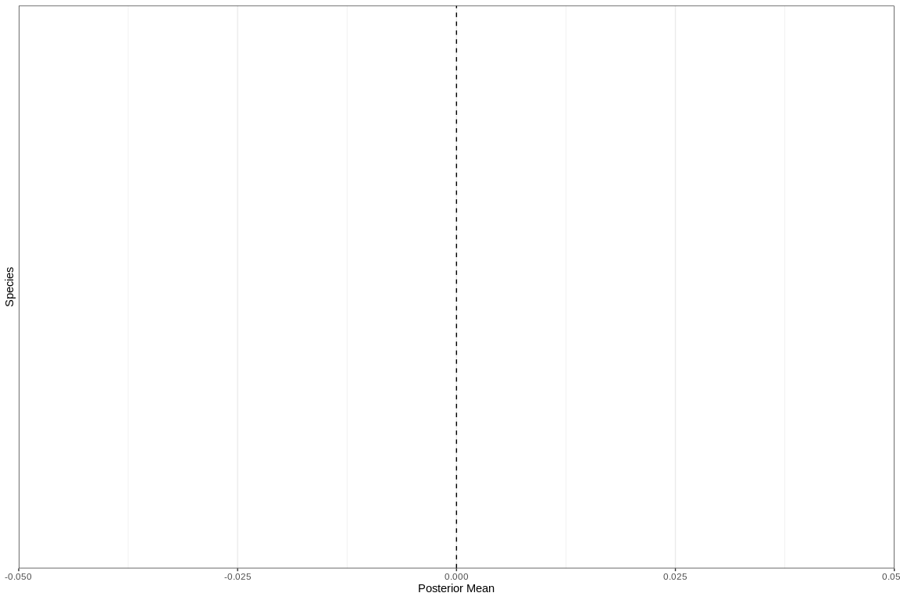

Mean regression coefficients (dots) and 95% credible intervals (bars) for effect of groundwater level on vegetation species cover abundances. Only those species with coefficients significanlty different to zero are shown

# Loch McNess

Five year summaries of surface water level data at Loch McNess

| Period | Mean max seasonal level (mAHD) | Mean min seasonal level (mAHD) | Mean seasonal change (m) | Month of maximum | Month of minimum | Mean max to min (days) |
| --- | --- | --- | --- | --- | --- | --- |
| 08/1994 - 07/1999 | 7.107 | 6.997 | 0.110 | September | March | 123.200 |
| 08/1999 - 07/2004 | 7.067 | 6.944 | 0.123 | July | March | 91.000 |
| 08/2004 - 07/2009 | 6.969 | 6.762 | 0.207 | June | February | 131.200 |
| 08/2009 - 07/2014 | 6.532 | 6.220 | 0.312 | October | May | 229.000 |
| 08/2014 - 07/2019 | 6.250 | 6.140 | 0.110 | December | July | 25.000 |

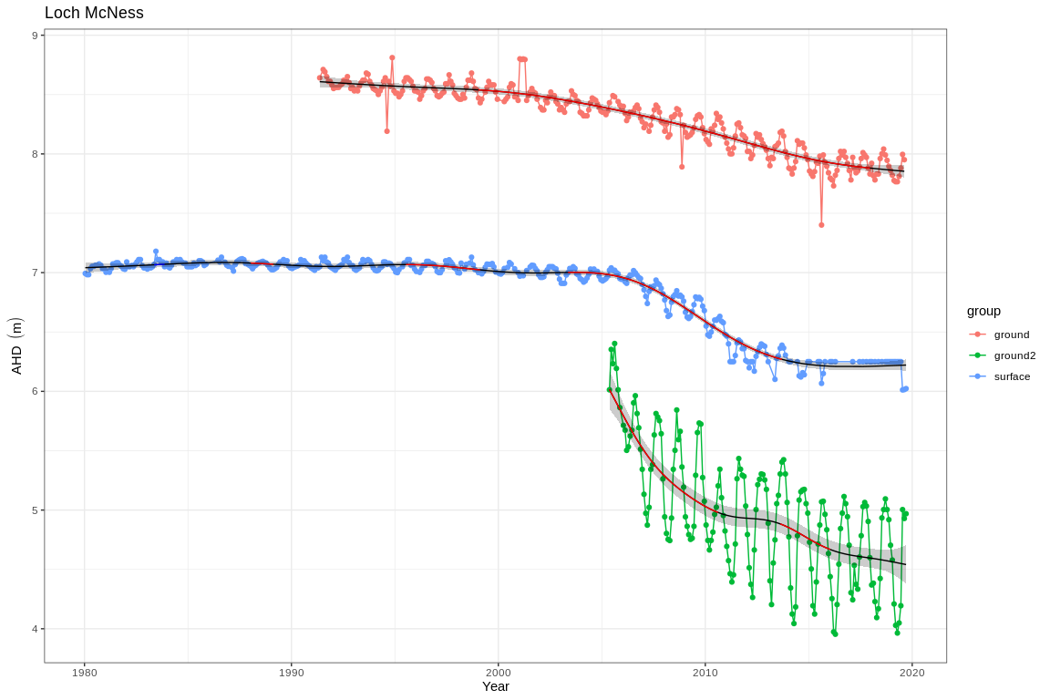

Ground and surface water levels recorded at bores and staff gauges in the vicinity of Loch McNess

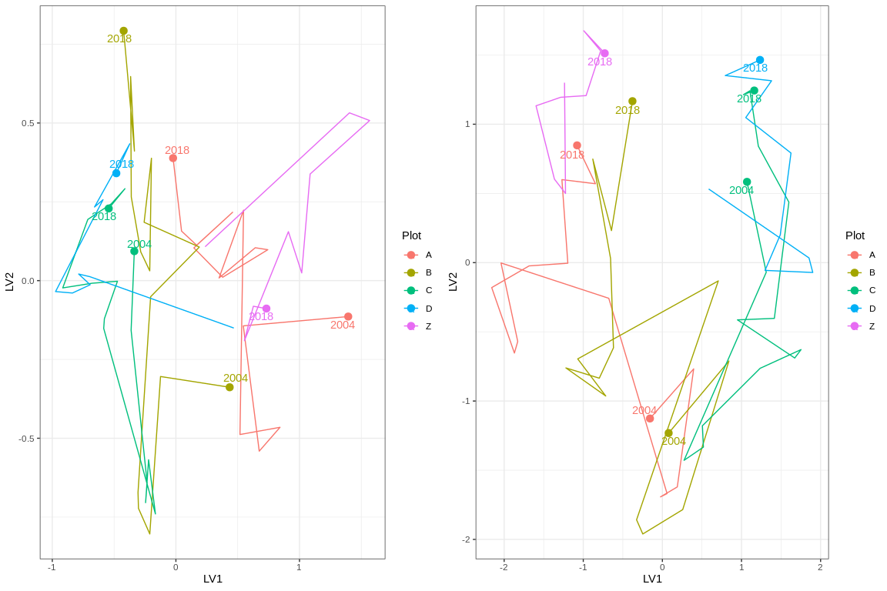

Ordination plot with full residual model on the left and a model on the right showing residual variation after the effect of groundwater levels were accounted for

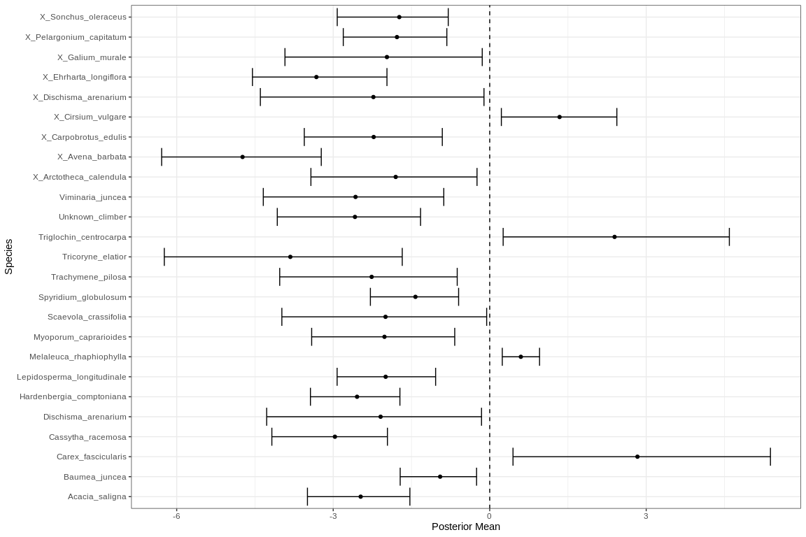

Mean regression coefficients (dots) and 95% credible intervals (bars) for effect of groundwater level on vegetation species cover abundances. Only those species with coefficients significanlty different to zero are shown

# Mariginiup

Five year summaries of surface water level data at Mariginiup

| Period | Mean max seasonal level (mAHD) | Mean min seasonal level (mAHD) | Mean seasonal change (m) | Month of maximum | Month of minimum | Mean max to min (days) |
| --- | --- | --- | --- | --- | --- | --- |
| 08/1994 - 07/1999 | 41.997 | 41.190 | 0.807 | September | February | 175.600 |
| 08/1999 - 07/2004 | 41.791 | 41.286 | 0.505 | October | July | 135.600 |
| 08/2004 - 07/2009 | 41.484 | 41.274 | 0.210 | September | July | 111.600 |
| 08/2009 - 07/2014 | 41.254 | 41.066 | 0.188 | October | January | 21.400 |
| 08/2014 - 07/2019 | 41.395 | 41.000 | 0.395 | September | January | 133.800 |

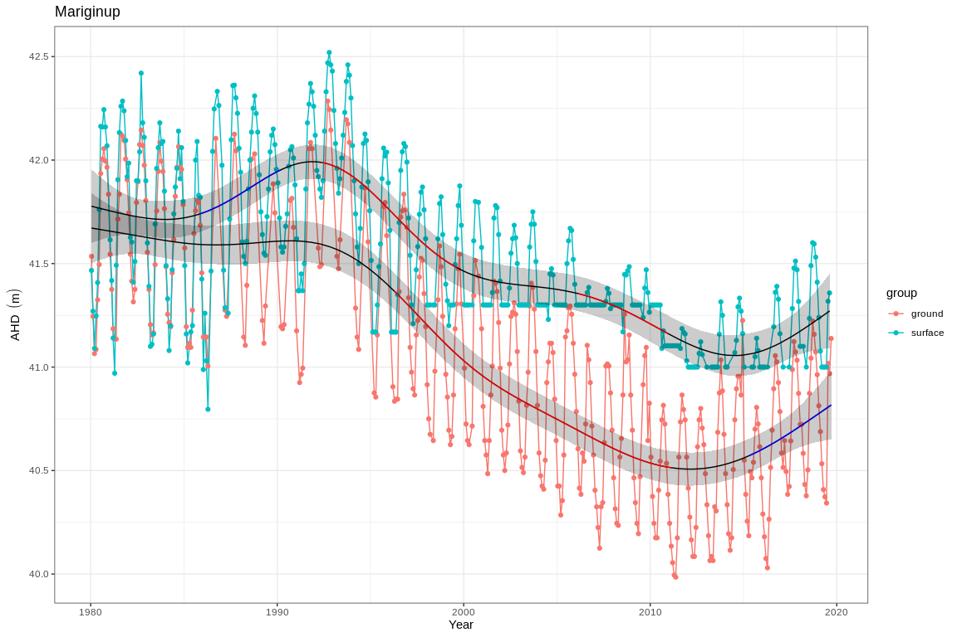

Ground and surface water levels recorded at bores and staff gauges in the vicinity of Mariginiup

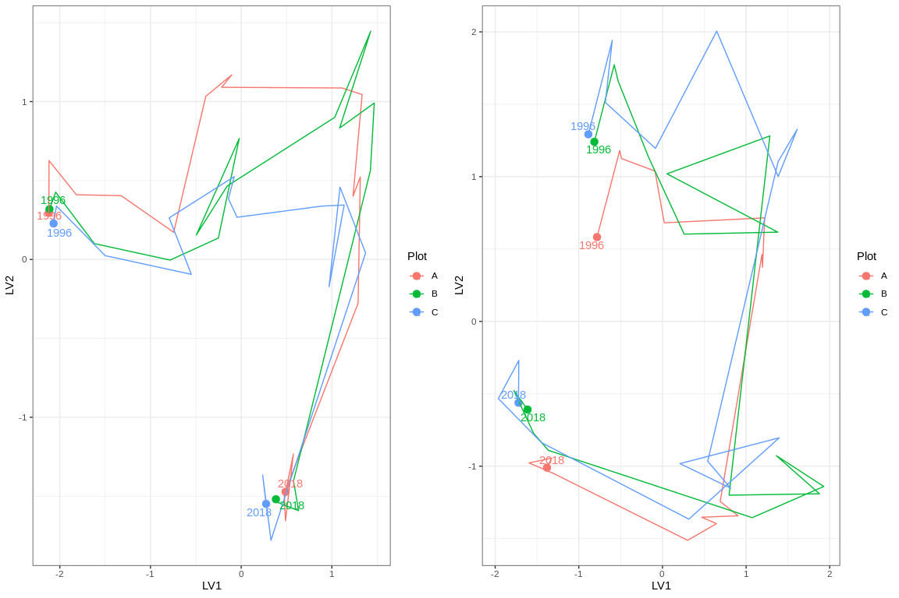

Ordination plot with full residual model on the left and a model on the right showing residual variation after the effect of groundwater levels were accounted for

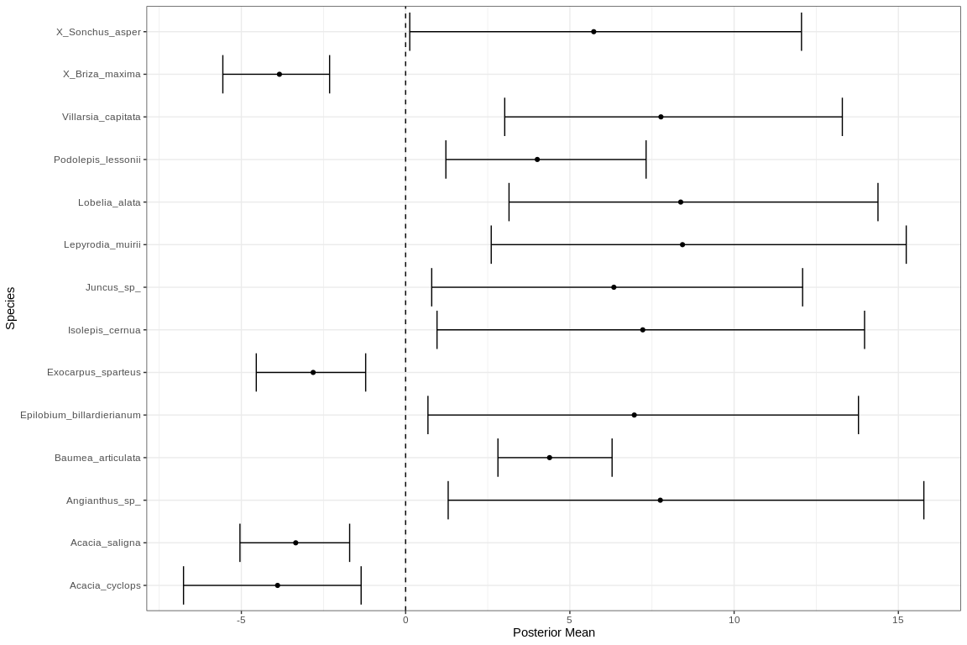

Mean regression coefficients (dots) and 95% credible intervals (bars) for effect of groundwater level on vegetation species cover abundances. Only those species with coefficients significanlty different to zero are shown

# MM59B

Five year summaries of surface water level data at MM59B

| Period | Mean max seasonal level (mAHD) | Mean min seasonal level (mAHD) | Mean seasonal change (m) | Month of maximum | Month of minimum | Mean max to min (days) |
| --- | --- | --- | --- | --- | --- | --- |
| 08/1994 - 07/1999 | 18.880 | 18.002 | 0.878 | September | May | 221.200 |
| 08/1999 - 07/2004 | 18.614 | 17.794 | 0.820 | October | April | 188.400 |
| 08/2004 - 07/2009 | 18.606 | 17.926 | 0.680 | October | March | 144.000 |
| 08/2009 - 07/2014 | 18.768 | 18.079 | 0.689 | October | May | 205.600 |
| 08/2014 - 07/2019 | 19.036 | 18.439 | 0.597 | September | April | 223.800 |

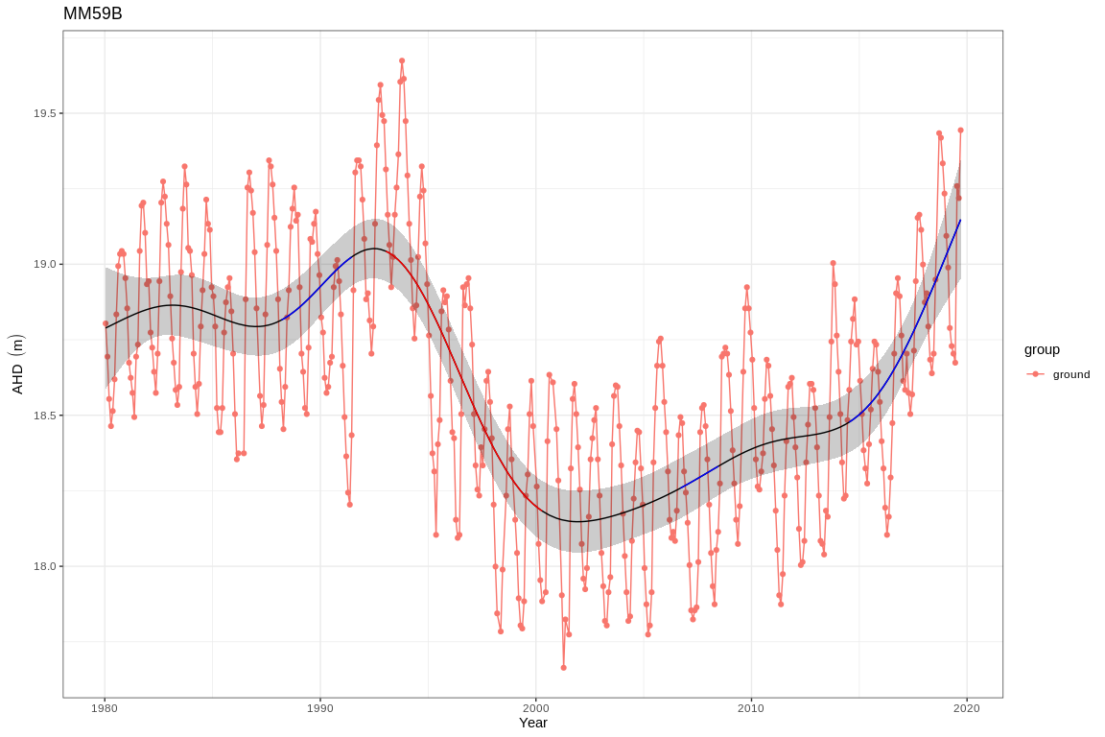

Ground and surface water levels recorded at bores and staff gauges in the vicinity of MM59B

# Nowergup

Five year summaries of surface water level data at Nowergup

| Period | Mean max seasonal level (mAHD) | Mean min seasonal level (mAHD) | Mean seasonal change (m) | Month of maximum | Month of minimum | Mean max to min (days) |
| --- | --- | --- | --- | --- | --- | --- |
| 08/1994 - 07/1999 | 17.005 | 16.166 | 0.839 | October | May | 114.800 |
| 08/1999 - 07/2004 | 16.687 | 15.964 | 0.723 | October | May | 20.400 |
| 08/2004 - 07/2009 | 16.777 | 16.216 | 0.561 | October | September | -1.400 |
| 08/2009 - 07/2014 | 16.161 | 15.988 | 0.173 | September | December | 78.800 |
| 08/2014 - 07/2019 | 16.000 | 15.615 | 0.385 | September | November | 56.400 |

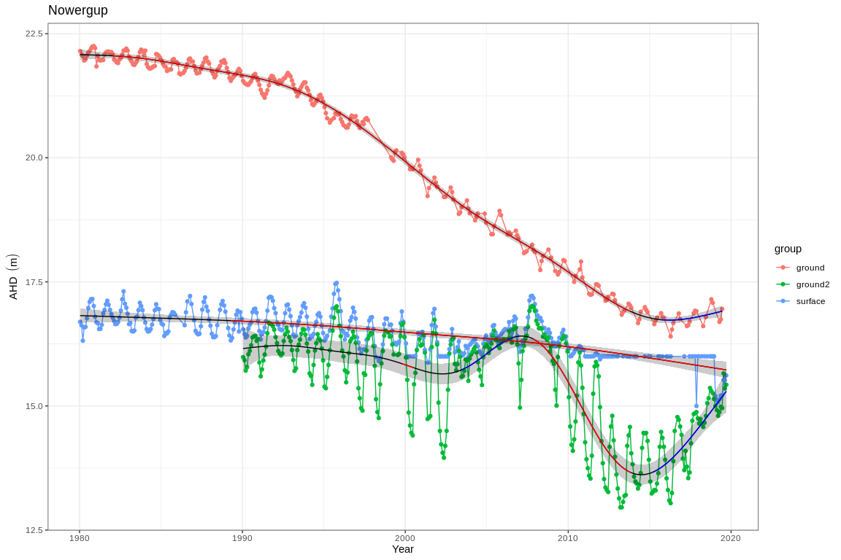

Ground and surface water levels recorded at bores and staff gauges in the vicinity of Nowergup

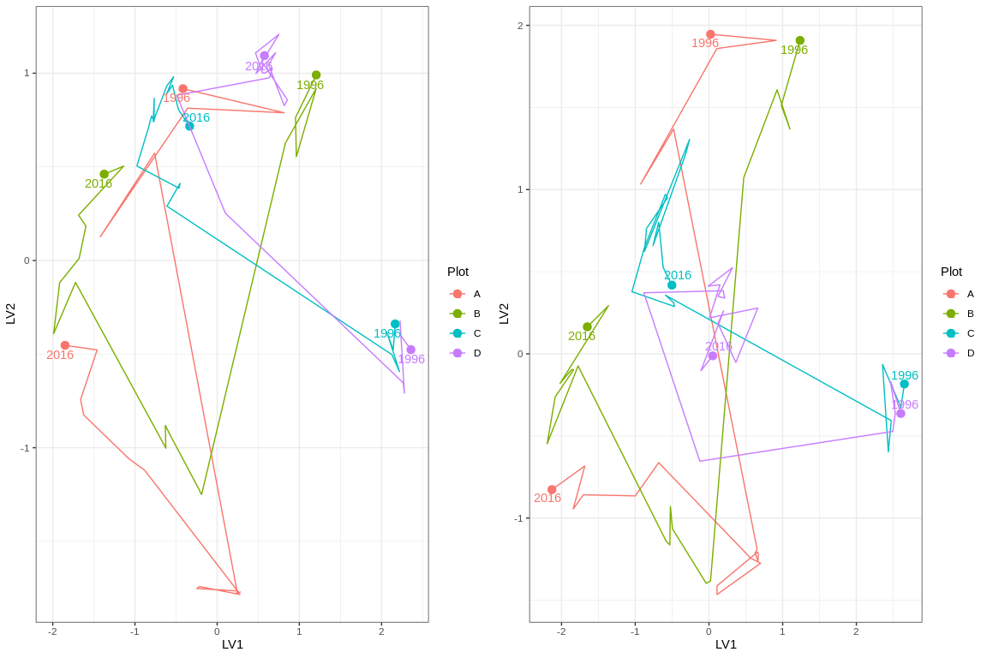

Ordination plot with full residual model on the left and a model on the right showing residual variation after the effect of groundwater levels were accounted for

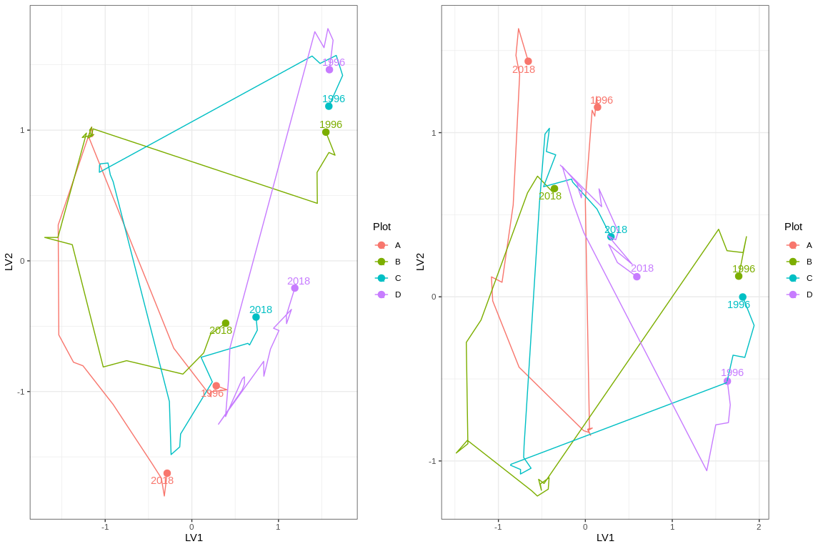

Ordination plot with full residual model on the left and a model on the right showing residual variation after the effect of groundwater levels were accounted for

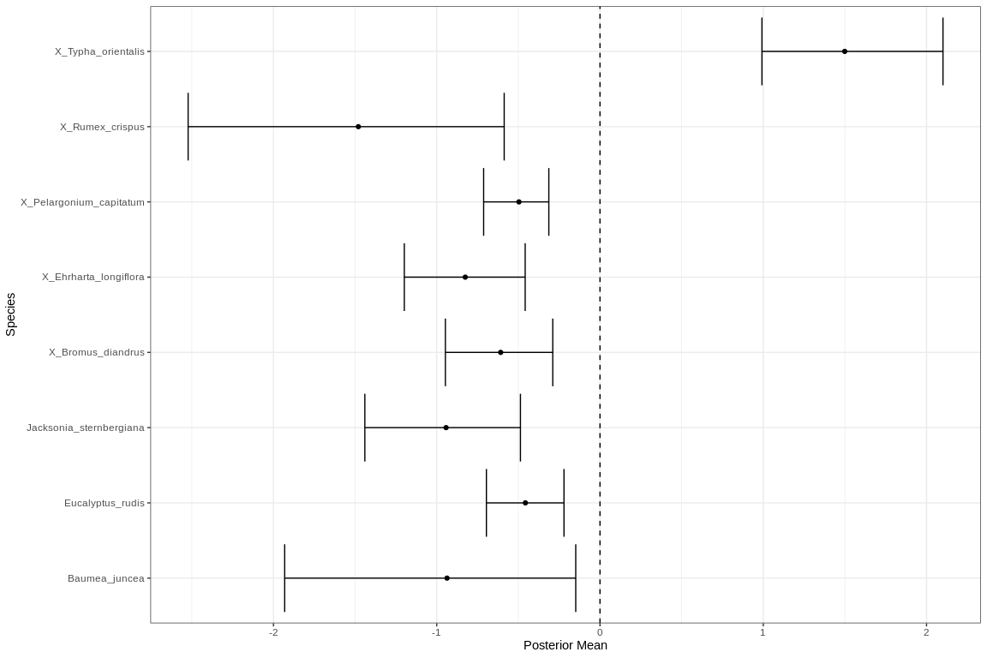

Mean regression coefficients (dots) and 95% credible intervals (bars) for effect of groundwater level on vegetation species cover abundances. Only those species with coefficients significanlty different to zero are shown

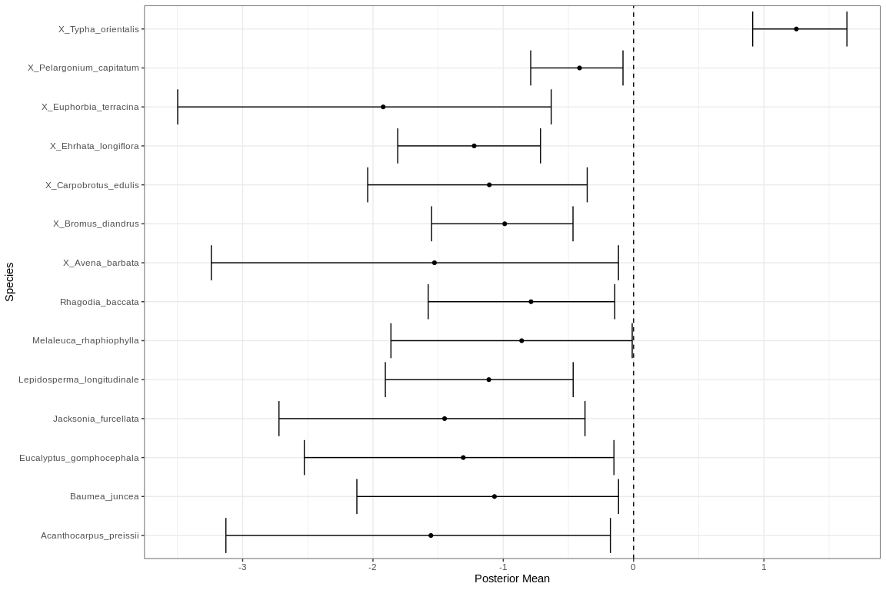

Mean regression coefficients (dots) and 95% credible intervals (bars) for effect of groundwater level on vegetation species cover abundances. Only those species with coefficients significanlty different to zero are shown

# Pipidinny

Five year summaries of surface water level data at Pipidinny

| Period | Mean max seasonal level (mAHD) | Mean min seasonal level (mAHD) | Mean seasonal change (m) | Month of maximum | Month of minimum | Mean max to min (days) |
| --- | --- | --- | --- | --- | --- | --- |
| 08/1994 - 07/1999 | 3.169 | 1.831 | 1.337 | September | May | 212.600 |
| 08/1999 - 07/2004 | 2.770 | 1.794 | 0.976 | October | March | 167.800 |
| 08/2004 - 07/2009 | 2.386 | 1.996 | 0.390 | September | November | 11.800 |
| 08/2009 - 07/2014 | 1.981 | 1.000 | 0.981 | October | July | 87.800 |
| 08/2014 - 07/2019 | 1.967 | 1.000 | 0.967 | September | January | 124.400 |

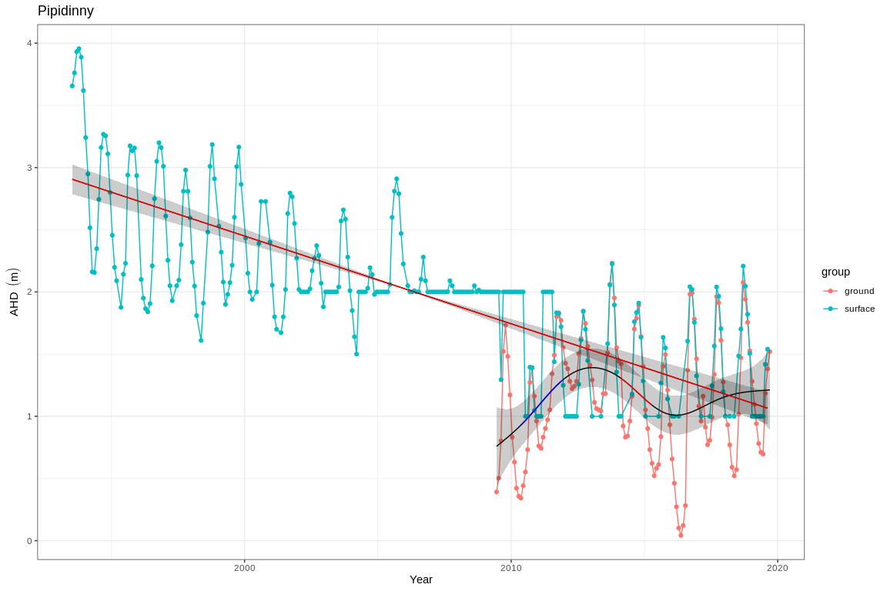

Ground and surface water levels recorded at bores and staff gauges in the vicinity of Pipidinny

# PM9

Five year summaries of surface water level data at PM9

| Period | Mean max seasonal level (mAHD) | Mean min seasonal level (mAHD) | Mean seasonal change (m) | Month of maximum | Month of minimum | Mean max to min (days) |
| --- | --- | --- | --- | --- | --- | --- |
| 08/1994 - 07/1999 | 58.436 | 57.708 | 0.728 | November | June | 251.600 |
| 08/1999 - 07/2004 | 57.500 | 56.822 | 0.678 | September | July | 201.200 |
| 08/2004 - 07/2009 | 56.516 | 56.022 | 0.494 | October | July | 256.800 |
| 08/2009 - 07/2014 | 55.179 | 54.738 | 0.441 | November | September | 206.600 |
| 08/2014 - 07/2019 | 54.385 | 52.830 | 1.555 | December | May | 242.500 |

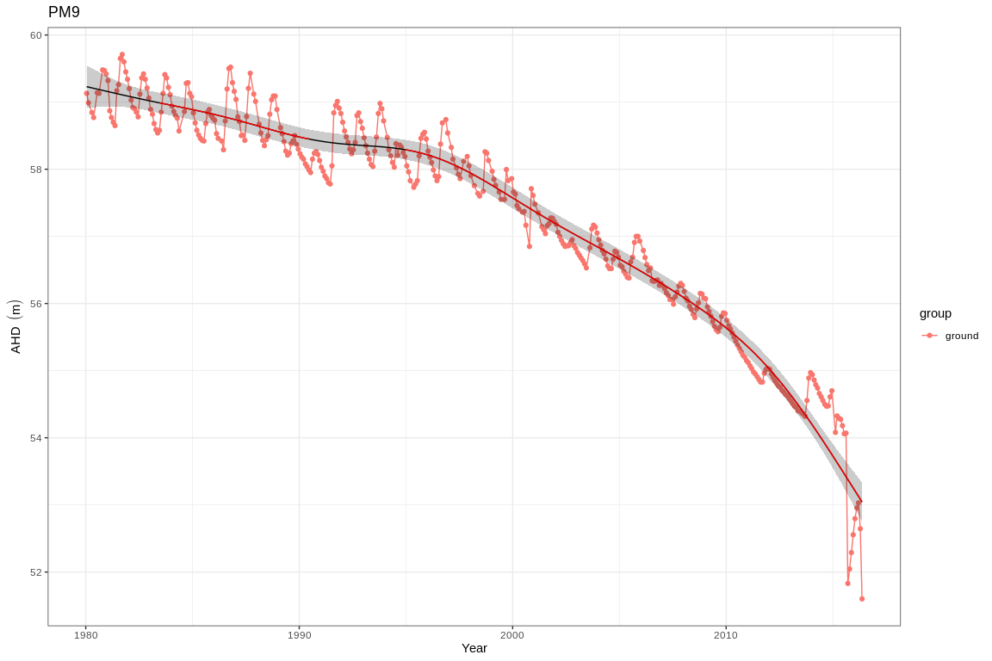

Ground and surface water levels recorded at bores and staff gauges in the vicinity of PM9

# Quin Brook

Five year summaries of surface water level data at Quin Brook

| Period | Mean max seasonal level (mAHD) | Mean min seasonal level (mAHD) | Mean seasonal change (m) | Month of maximum | Month of minimum | Mean max to min (days) |
| --- | --- | --- | --- | --- | --- | --- |
| 08/1994 - 07/1999 | 59.032 | 58.774 | 0.258 | January | July | 125.200 |
| 08/1999 - 07/2004 | 58.224 | 58.064 | 0.160 | January | April | 93.400 |
| 08/2004 - 07/2009 | 57.109 | 56.864 | 0.245 | October | April | 203.200 |
| 08/2009 - 07/2014 | 55.572 | 55.430 | 0.142 | November | April | 196.000 |
| 08/2014 - 07/2019 | 54.122 | 54.013 | 0.109 | October | October | 47.200 |

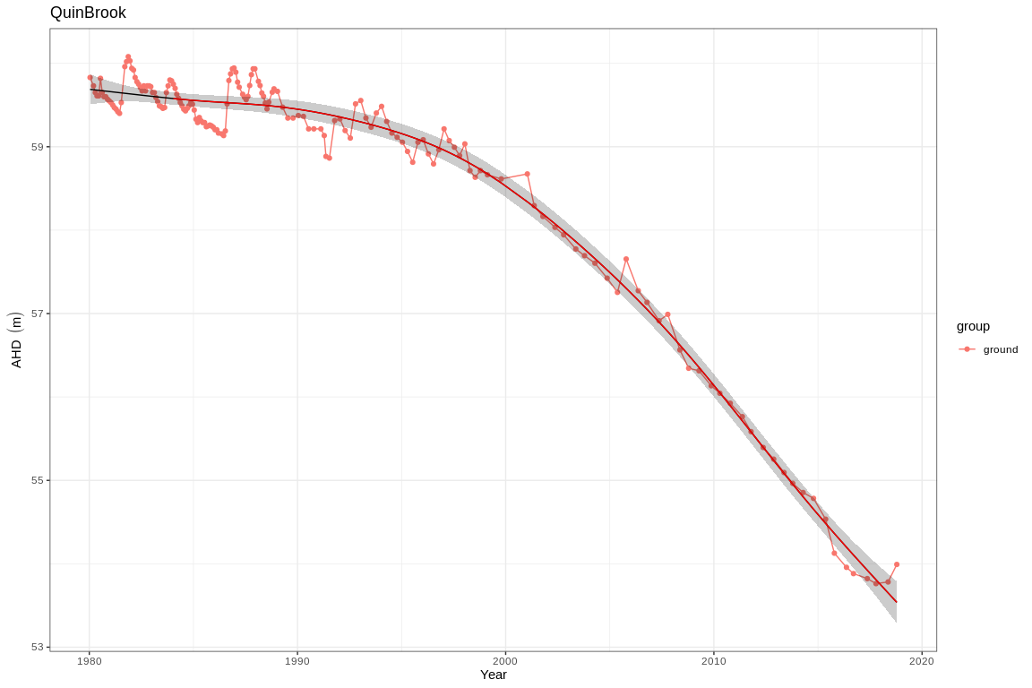

Ground and surface water levels recorded at bores and staff gauges in the vicinity of Quin Brook

# Wilgarup

Five year summaries of surface water level data at Wilgarup

| Period | Mean max seasonal level (mAHD) | Mean min seasonal level (mAHD) | Mean seasonal change (m) | Month of maximum | Month of minimum | Mean max to min (days) |
| --- | --- | --- | --- | --- | --- | --- |
| 08/1994 - 07/1999 | 5.220 | 4.310 | 0.910 | October | March | 184.500 |
| 08/1999 - 07/2004 | 4.745 | 4.017 | 0.728 | October | April | 193.400 |
| 08/2004 - 07/2009 | 4.327 | 3.705 | 0.622 | September | May | 150.000 |
| 08/2009 - 07/2014 | 3.816 | 3.222 | 0.594 | October | April | 190.400 |
| 08/2014 - 07/2019 | 3.632 | 3.085 | 0.547 | October | May | 212.400 |

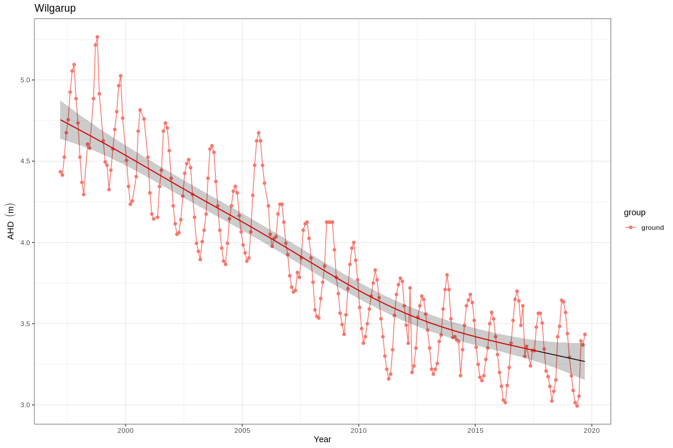

Ground and surface water levels recorded at bores and staff gauges in the vicinity of Wilgarup

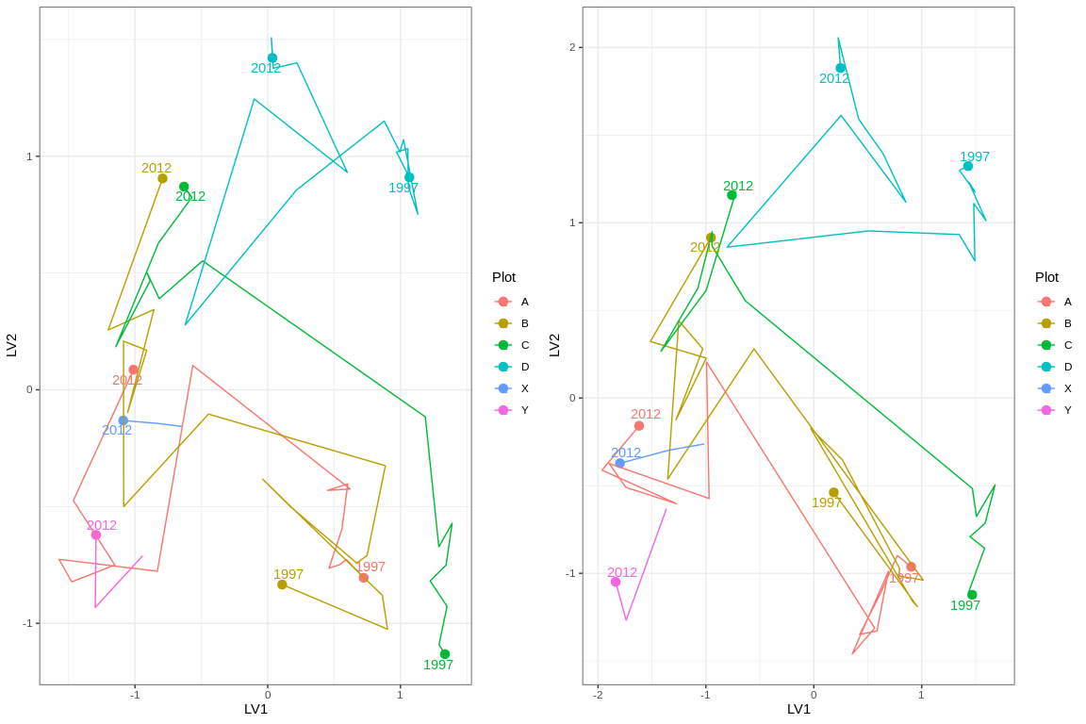

Ordination plot with full residual model on the left and a model on the right showing residual variation after the effect of groundwater levels were accounted for

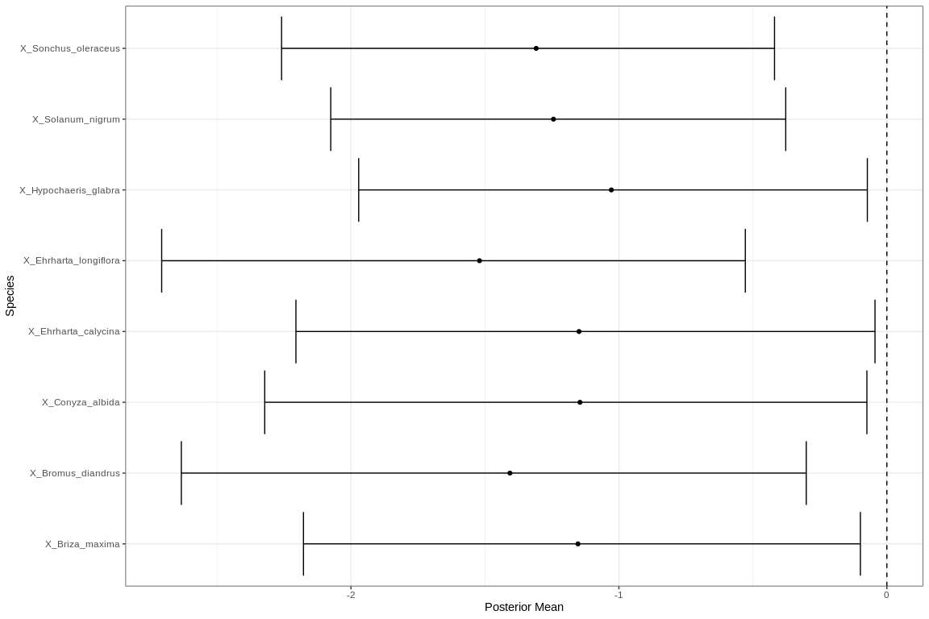

Mean regression coefficients (dots) and 95% credible intervals (bars) for effect of groundwater level on vegetation species cover abundances. Only those species with coefficients significanlty different to zero are shown

# WM1

Five year summaries of surface water level data at EMP 173

| Period | Mean max seasonal level (mAHD) | Mean min seasonal level (mAHD) | Mean seasonal change (m) | Month of maximum | Month of minimum | Mean max to min (days) |
| --- | --- | --- | --- | --- | --- | --- |
| 08/1994 - 07/1999 | 51.122 | 50.209 | 0.913 | October | March | 195.667 |
| 08/1999 - 07/2004 | 51.086 | 50.410 | 0.676 | September | April | 157.600 |
| 08/2004 - 07/2009 | 51.036 | 50.410 | 0.626 | August | January | 79.000 |
| 08/2009 - 07/2014 | 50.732 | 50.400 | 0.332 | October | February | 60.800 |
| 08/2014 - 07/2019 | 50.804 | 50.400 | 0.404 | September | January | 85.600 |

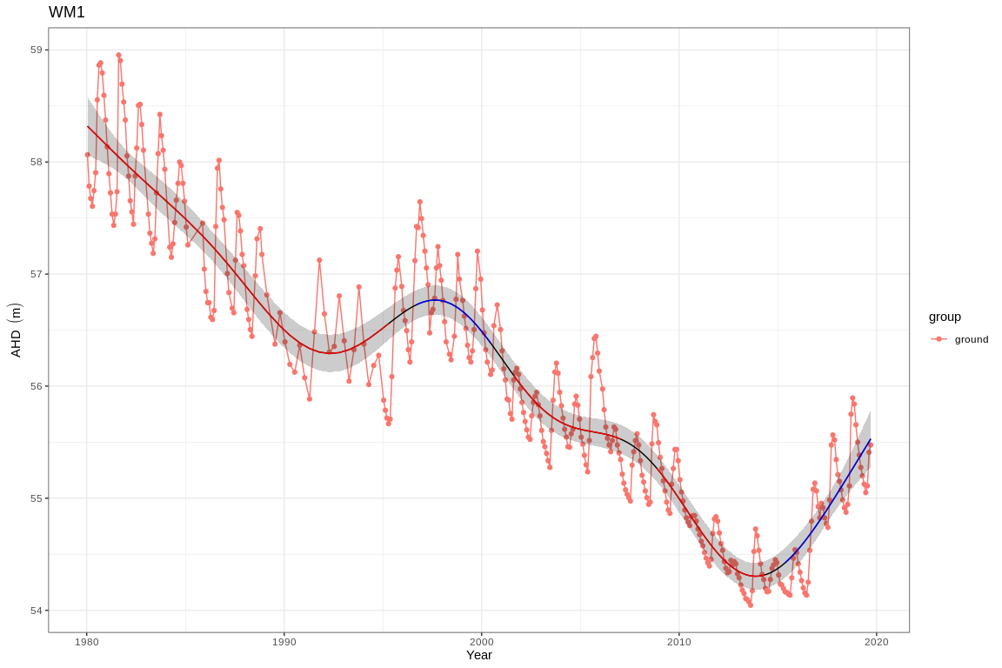

Ground and surface water levels recorded at bores and staff gauges in the vicinity of WM1

# WM2

Five year summaries of surface water level data at WM2

| Period | Mean max seasonal level (mAHD) | Mean min seasonal level (mAHD) | Mean seasonal change (m) | Month of maximum | Month of minimum | Mean max to min (days) |
| --- | --- | --- | --- | --- | --- | --- |
| 08/1994 - 07/1999 | 51.122 | 50.209 | 0.913 | October | March | 195.667 |
| 08/1999 - 07/2004 | 51.086 | 50.410 | 0.676 | September | April | 157.600 |
| 08/2004 - 07/2009 | 51.036 | 50.410 | 0.626 | August | January | 79.000 |
| 08/2009 - 07/2014 | 50.732 | 50.400 | 0.332 | October | February | 60.800 |
| 08/2014 - 07/2019 | 50.804 | 50.400 | 0.404 | September | January | 85.600 |

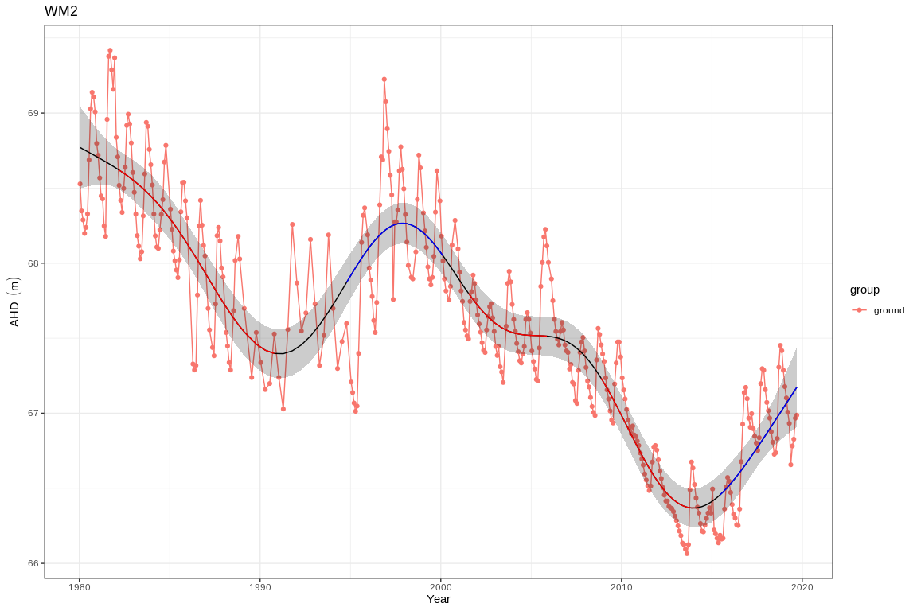

Ground and surface water levels recorded at bores and staff gauges in the vicinity of WM2

# WM8

Five year summaries of surface water level data at WM8

| Period | Mean max seasonal level (mAHD) | Mean min seasonal level (mAHD) | Mean seasonal change (m) | Month of maximum | Month of minimum | Mean max to min (days) |
| --- | --- | --- | --- | --- | --- | --- |
| 08/1994 - 07/1999 | 66.313 | 65.661 | 0.652 | October | July | 230.200 |
| 08/1999 - 07/2004 | 66.013 | 65.485 | 0.528 | December | June | 180.000 |
| 08/2004 - 07/2009 | 65.609 | 65.209 | 0.400 | November | July | 256.000 |
| 08/2009 - 07/2014 | 65.007 | 64.651 | 0.356 | November | August | 200.200 |
| 08/2014 - 07/2019 | 65.029 | 64.703 | 0.326 | December | July | 29.600 |

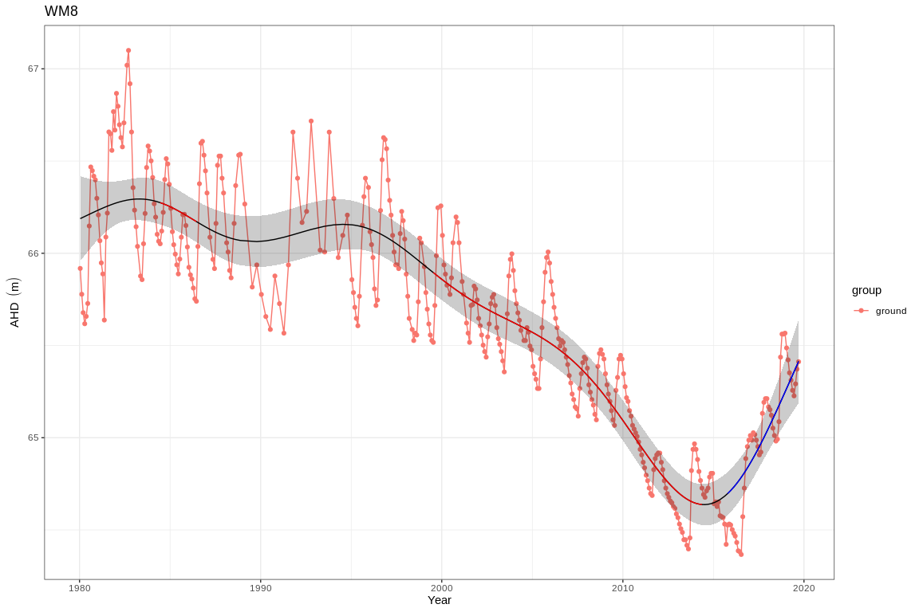

Ground and surface water levels recorded at bores and staff gauges in the vicinity of WM8

# Yonderup

Five year summaries of surface water level data at Yonderup

| Period | Mean max seasonal level (mAHD) | Mean min seasonal level (mAHD) | Mean seasonal change (m) | Month of maximum | Month of minimum | Mean max to min (days) |
| --- | --- | --- | --- | --- | --- | --- |
| 08/1994 - 07/1999 | 5.993 | 5.924 | 0.069 | August | September | 82.400 |
| 08/1999 - 07/2004 | 5.959 | 5.901 | 0.058 | September | February | 143.600 |
| 08/2004 - 07/2009 | 5.921 | 5.862 | 0.059 | April | April | 130.200 |
| 08/2009 - 07/2014 | 5.867 | 5.681 | 0.186 | September | April | 211.800 |
| 08/2014 - 07/2019 | 5.808 | 5.557 | 0.251 | September | March | 218.400 |

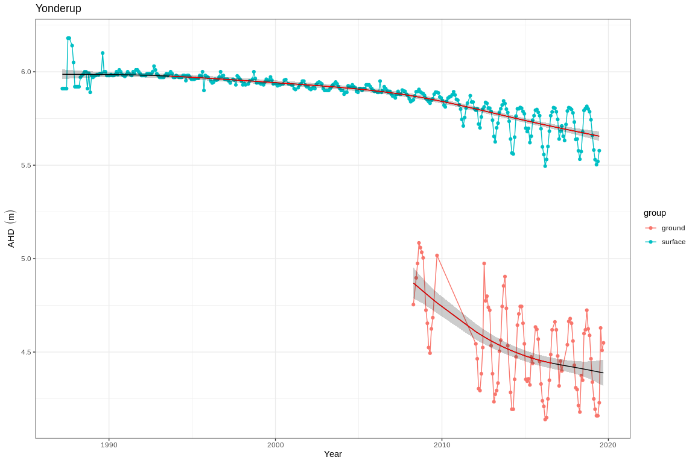

Ground and surface water levels recorded at bores and staff gauges in the vicinity of Yonderup

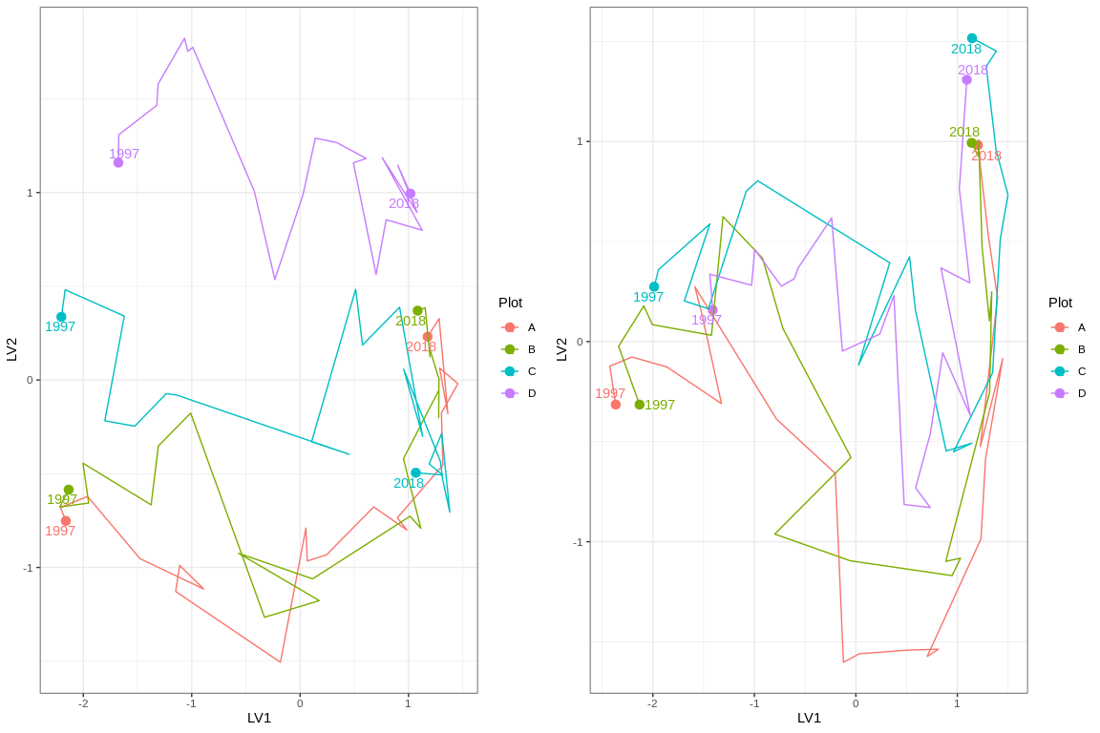

Ordination plot with full residual model on the left and a model on the right showing residual variation after the effect of groundwater levels were accounted for

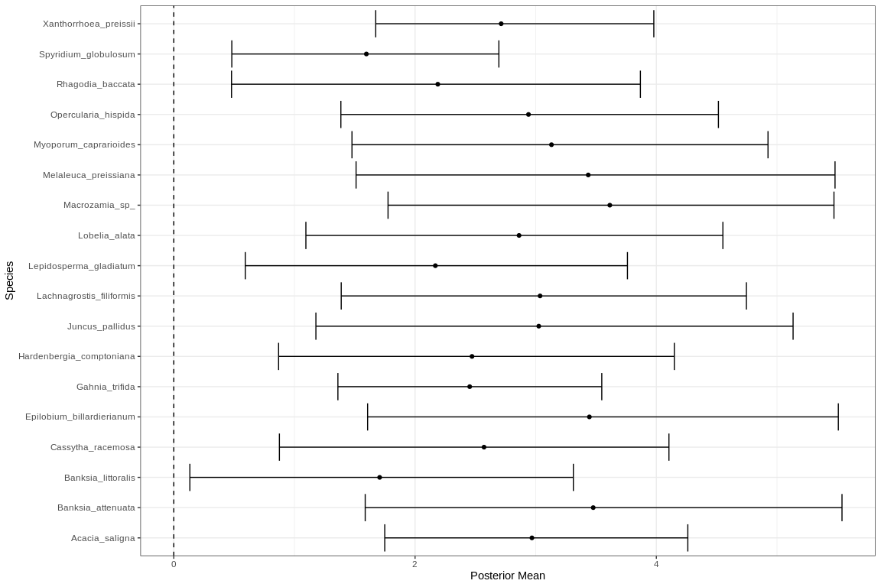

Mean regression coefficients (dots) and 95% credible intervals (bars) for effect of groundwater level on vegetation species cover abundances. Only those species with coefficients significanlty different to zero are shown